Information, Resources & tips to promote
Early years/ Primary reading

Open the ‘HomeTime’ Cupboard
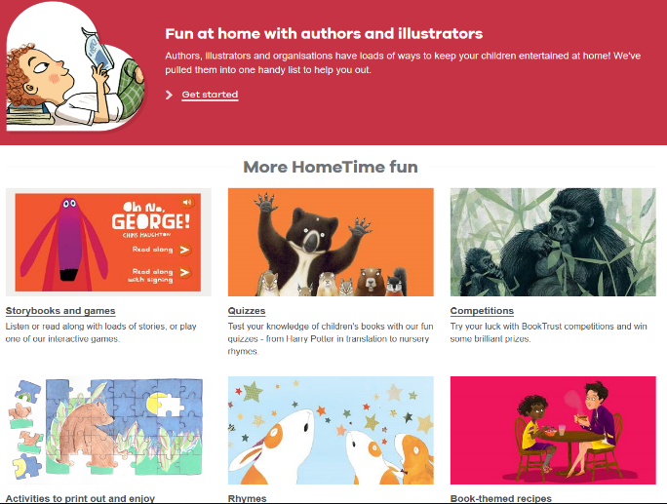
Head to Book Trust to find lots of high quality, engaging books and activities!

You will find top authors reading their stories, videos of famous illustrators teaching children how to draw, activities and games.

https://www.booktrust.org.uk/books-and-reading/have-some-fun/open-the-hometime-cupboard/

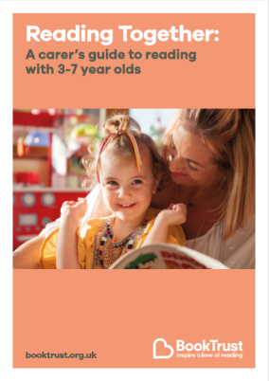
They have also published a guide to support foster carers to promote reading at home - https://www.booktrust.org.uk/books-and-reading/tips-and-advice/reading-tips/reading-tips-for-carers-and-foster-families/

Audiobooks
Did you know that listening to audiobooks can improve children’s attention span, imagination and can aid their mental well-being?
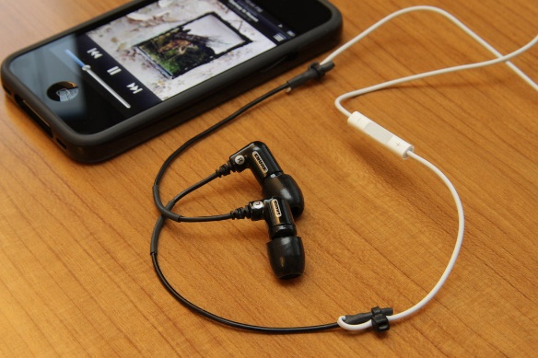
You can download audiobooks onto your phone, tablet or computer either through subscription based apps such as Audible and Kobo, or via an à la carte service, such as Google Play or the iTunes store. You can also stream audiobooks on Bookbeat or Spotify. Libraries have lots of CD audiobooks, or if you have a smart speaker like Alexa or Google Home, you could ask for a free children’s story.

Visit https://www.harpercollinschildrensbooks.co.uk/listen-for-free/
for more information
‘1 in 2 children and young people say that listening to audiobooks has increased their interest in reading, and 2 in 5 say that it has made them more interested in writing’
-National Literacy Trust report, 2020

If you need a book to help your child with a situation or topic, Little Parachutes list a wide range of books. There are picture books on milestones like starting school, moving house and hundreds of book recommendations about challenging situations like bereavement, exploring feelings and books about developing resilience, confidence, courage, and gratitude.

