Ideas & Activities to promote reading in the Early Years
Reading gives children a wealth of new vocabulary, of information about stories that they can relate to, experiences they can label and new or imaginary worlds that helps them to develop their imagination.

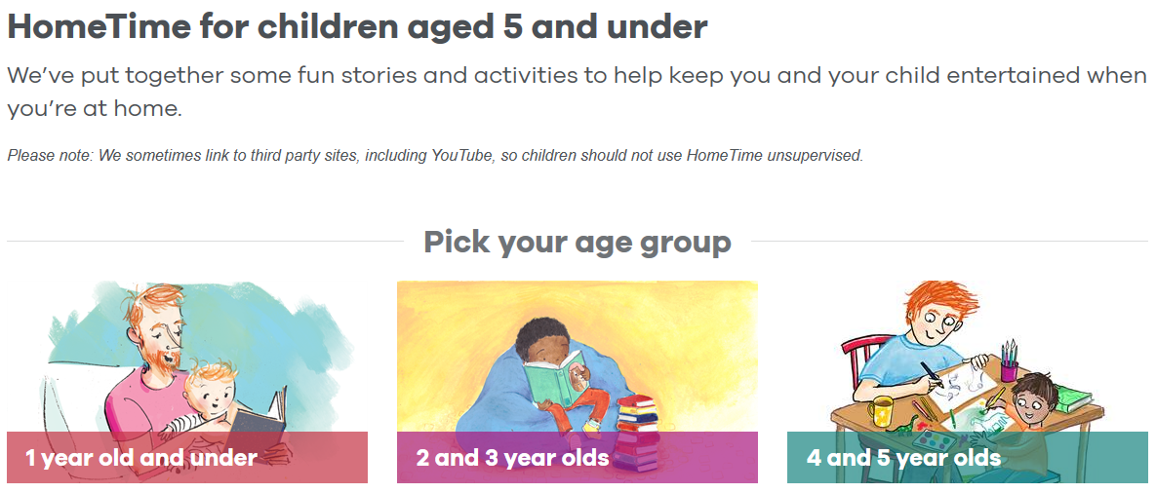

The Booktrust website has lots of fantastic reading resources, including a ‘book finder’ tool and it’s ‘Hometime’ section is full of story clips and activities, all categorised by age.

Teach Your Monster to Read
The Teach Your Monster to Read website and app encourages children to teach their own ‘monster’ character early reading skills, from matching letters and sounds to short stories.
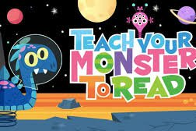

Hungry Little Minds
Talk is the foundation of reading. Children learn new vocabulary through speaking and listening and spending time with you, developing attachment, communication and play skills will aid their learning across the curriculum.

Hungry Little Minds offers a fantastic range of age-appropriate activities that you could try at home, all of which aid learning and development in line with the EYFS framework.

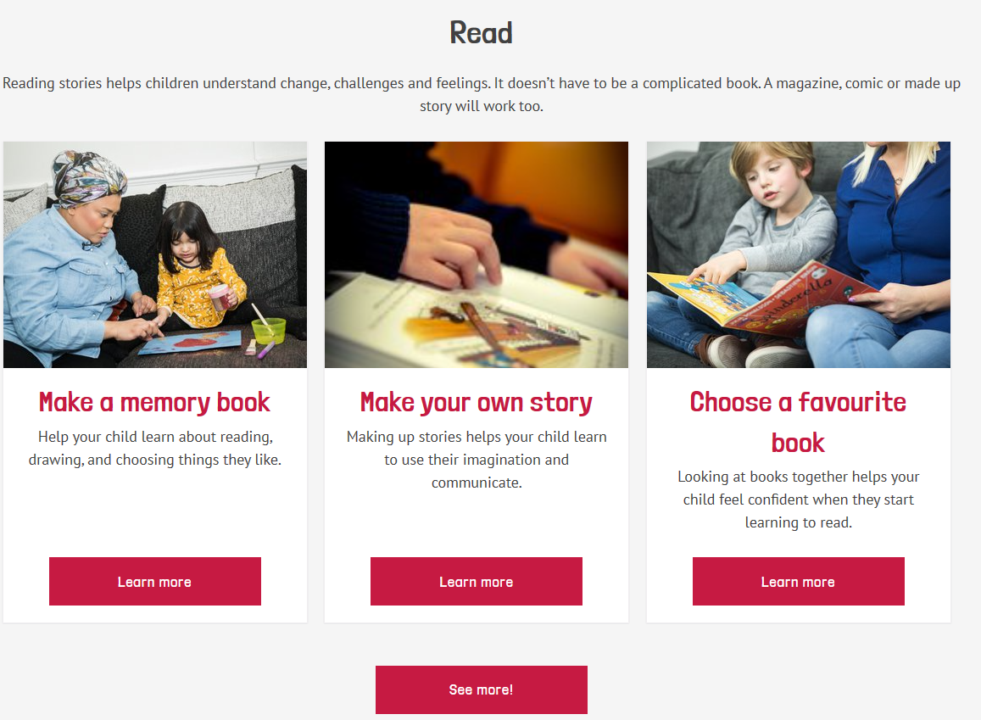

Learning through play and everyday activities

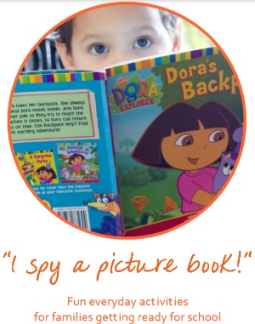
Visit Words for Life to download an ‘I spy Activity book with everyday activities to do with pre-school children. Encourage lots of description and explanation to expand their thinking and use of vocabulary.

Here to support you
If you’d like more ideas or advice to support reading for the child that you’re fostering, feel free to contact Sara Martin, Early Years and Primary Specialist at Sutton Virtual School on sara.martin@cognus.org.uk.

