What is anxiety?
Imagine you are walking through the jungle and you come across a tiger….. What might you be thinking?

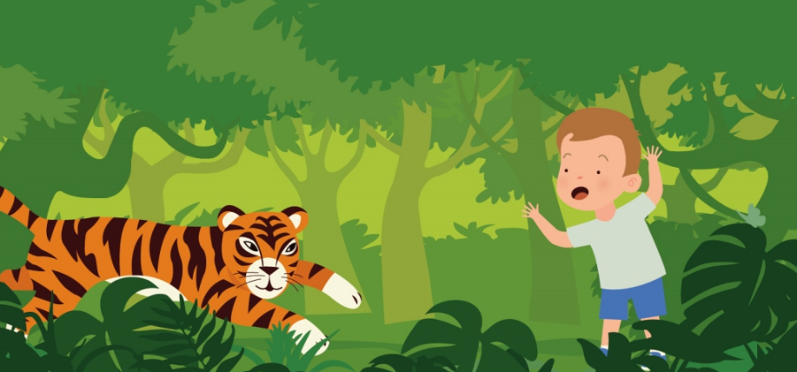

Because of this thought our body starts to change….colour in the changes to the body that you think might happen
Pupils in the eye get bigger
Increased blood pressure
Increased Adrenaline
Sit down and have a rest
Increased breathing rate
Jump up and down excited
Blood flows to key muscles and the brain
Walk closer
We fall asleep
Body temperature becomes hotter
Muscles tense
Increased heart rate and pulse

This is our body’s way of preparing us to survive from the tiger or any other real life danger
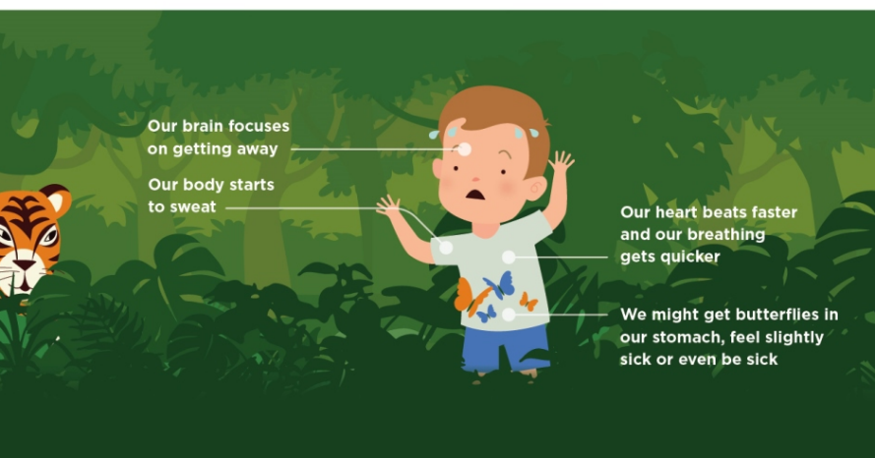

By making all the above physical changes, our body is now ready to help us to:
Roll on the floor
Think faster
Stand still
Become out of breath
Fall to the floor
See and hear better
Fight harder
Heal better
Take a slow walk away
Jump Higher
Relax
Run Faster

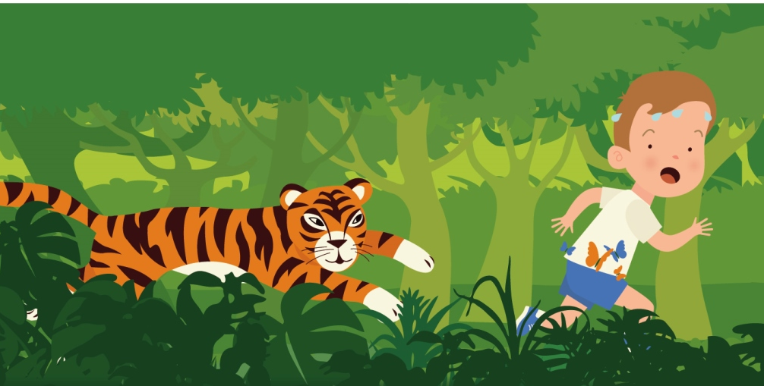

These changes to our body help to survive against the tiger by either:
- Protecting himself through fighting back (fight)
- Protecting himself through running away to safety (flight)
- Protecting himself by staying still so the tiger leaves him alone (freeze)

This is known as the fight, flight or freeze response. This response can be helpful but only if there is real danger and we calm down soon after – sometimes we feel like this even though there isn’t any danger and this feeling doesn’t calm down.

What does this have to do with anxiety?
We may sometimes feel like this even when tigers aren’t around. For example, you may get worried about going to school or going to a shopping centre.
When you get these feelings, you may want to try and stay away from the place that makes you feel like this, because you believe that something scary will happen. For example; not going to school.
An Example
Imagine you have a party to go to. This should be a fun thing, but what if you start to think about all the bad things that might happen if you went to the party?
Are you viewing the party as safe or dangerous?

Safe

Dangerous

Why?.......................................................................................................................................................................................................................................................................................................................................................................................................................................................................................................................................................................................................

But is the party a real danger?

Yes

No
Why?.......................................................................................................................................................................................................................................................................................................................................................................................................................................................................................................................................................................................................
If we think places are more dangerous than they actually are, we will keep having the fight, flight or freeze false response. As a result our bodies get stuck in this fight, flight or freeze mode – THIS IS ANXIETY.
It is important to let someone know
If you feel anxious, it is important to talk to your parents, carers or an adult who you trust. Let them know how you feel so they know how they can support you. Don’t worry – they will be able to help so that you don’t have to manage these feelings all the time.
Who is someone you could tell? …………………………

When is a time you have felt anxious?
………………………………………………………………………………………………………………………………………………………………………………………………………………………………………………………………………………………………………………………………………………………………………………………………………………………………………………………………………………………………………………………………………………………………………………………………………………………………………………………………………………………………………………………………………………………………………………………………………………………………………………………………………………………………………………………………………………………………………………………………………………………………………………………………………………………………………………………………………………………………………………………………………………………………………………………………………………………………………………………………………………………………………………………………………………………………………………………………………………………………

