BOOKS THAT REFLECT TRAVELLER CULTURE

AGE | COVER | TITLE | AUTHOR | PUBLISHER | ISBN
EYFS /  KS1 | 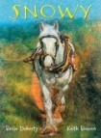 | Snowy | Berlie Doherty | Troika Books | ISBN-10:‎ 0957301391  ISBN-13:978-0957301399
EYFS / KS1 | 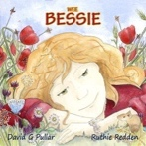 | Wee Bessie | David Pullar | Hott Press | ISBN-10: 1527244229  ISBN-13:‎ 978-1527244221
KS1 | 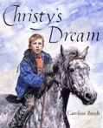 | Christy’s Dream | Caroline Binch | Frances Lincoln | ISBN-10:‎ 0749742941  ISBN-13:‎978-0749742942
KS1/2 |  | Go Away Eddie | Scott Leaver | Sutton & Merton Traveller Education Service (Cognus Ltd)
KS1/2 |  | Wally’s First Boxing Match | Michaela Williams | Sutton & Merton Traveller Education Service (Cognus Ltd)
KS1/2 |  | Wally’s First Football Match | George Sparrowhawk | Sutton & Merton Traveller Education Service (Cognus Ltd)
KS1/2 | 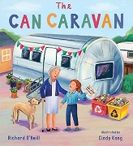 | The Can Caravan | Richard O'Neill | Child's Play | ISBN-10: 1786286149  ISBN-13:‎ 978-1786286147
KS1/2 | 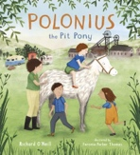 | Polonius the Pit Pony | Richard O'Neill | Child's Play | ISBN-10 ‏ : 1786281856  ISBN-13: ‎978-1786281852
KS1/2 | 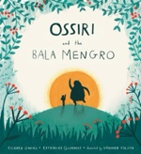 | Ossiri and the Bala Mengro (Travellers Tales) | Richard O'Neill | Child's Play | ISBN-10:‎ 1846439248  ISBN-13:‎978-1846439247
KS1/2 | 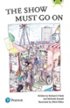 | The Show Must Go On | Michelle Russell /Richard O’Neill | Pearson | ISBN-10: ‎1292372419  ISBN-13:‎ 978-1292372419
KS1/2 | 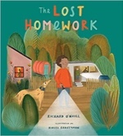 | The Lost Homework | Richard O’Neill | Child’s Play | ISBN-10:‎ 178628345X  ISBN-13:978-1786283450
KS1/2 | 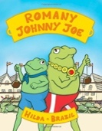 | Romany Johnny Joe | Hilda Brazil | Athena Press | ISBN-10:‎ 1847485561  ISBN-13:‎978-1847485564
KS2 | 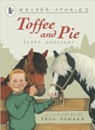 | Toffee and Pie | Pippa Goodhart | Walker | ISBN-10:‎ 1406311367  ISBN-13:‎ 978-1406311365
KS2 | 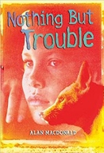 | Nothing But Trouble | Alan MacDonald | A & C Black | ISBN-10:‎ 0713676795  ISBN-13:‎978-0713676792
KS3/4 | 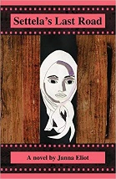 | Settela’s Last Road | Janna Eliot | Trafford Publishing | ISBN-10:‎ 1425157025  ISBN-13:‎ 978-1425157029
KS3/4 |  | Fight game | Kate Wild | Chicken House | ISBN-10:‎ 1905294239  ISBN-13:978-1905294237
KS3/4 | 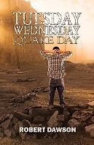 | Tuesday Wednesday Quake Day | Robert Dawson | Austin Macauley Publishers Ltd. | ISBN-10:‎ 178629527X  ISBN-13:978-1786295279
KS3/4 | 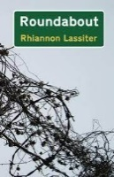 | Roundabout | Rhiannon Lassiter | CreateSpace Independent Publishing Platform | ISBN-10: 1493798898  ISBN-13:978-1493798896
KS3/4 | 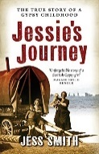 | Jessie's Journey: Autobiography of a Traveller Girl | Jess Smith | Birlinn | ISBN-13:978-1841587028
Adults | 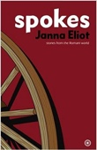 | Spokes: Stories from the Romani World | Janna Eliot | Five Leaves Publications | ISBN-10:‎ 1905512473  ISBN-13:‎ 978-1905512478

