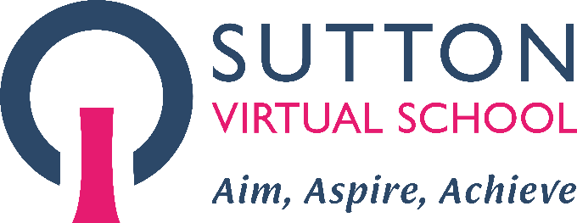
Sutton Virtual School
New to Care Pack
Visit our website
Follow us on Twitter @SuttonVS_CLA

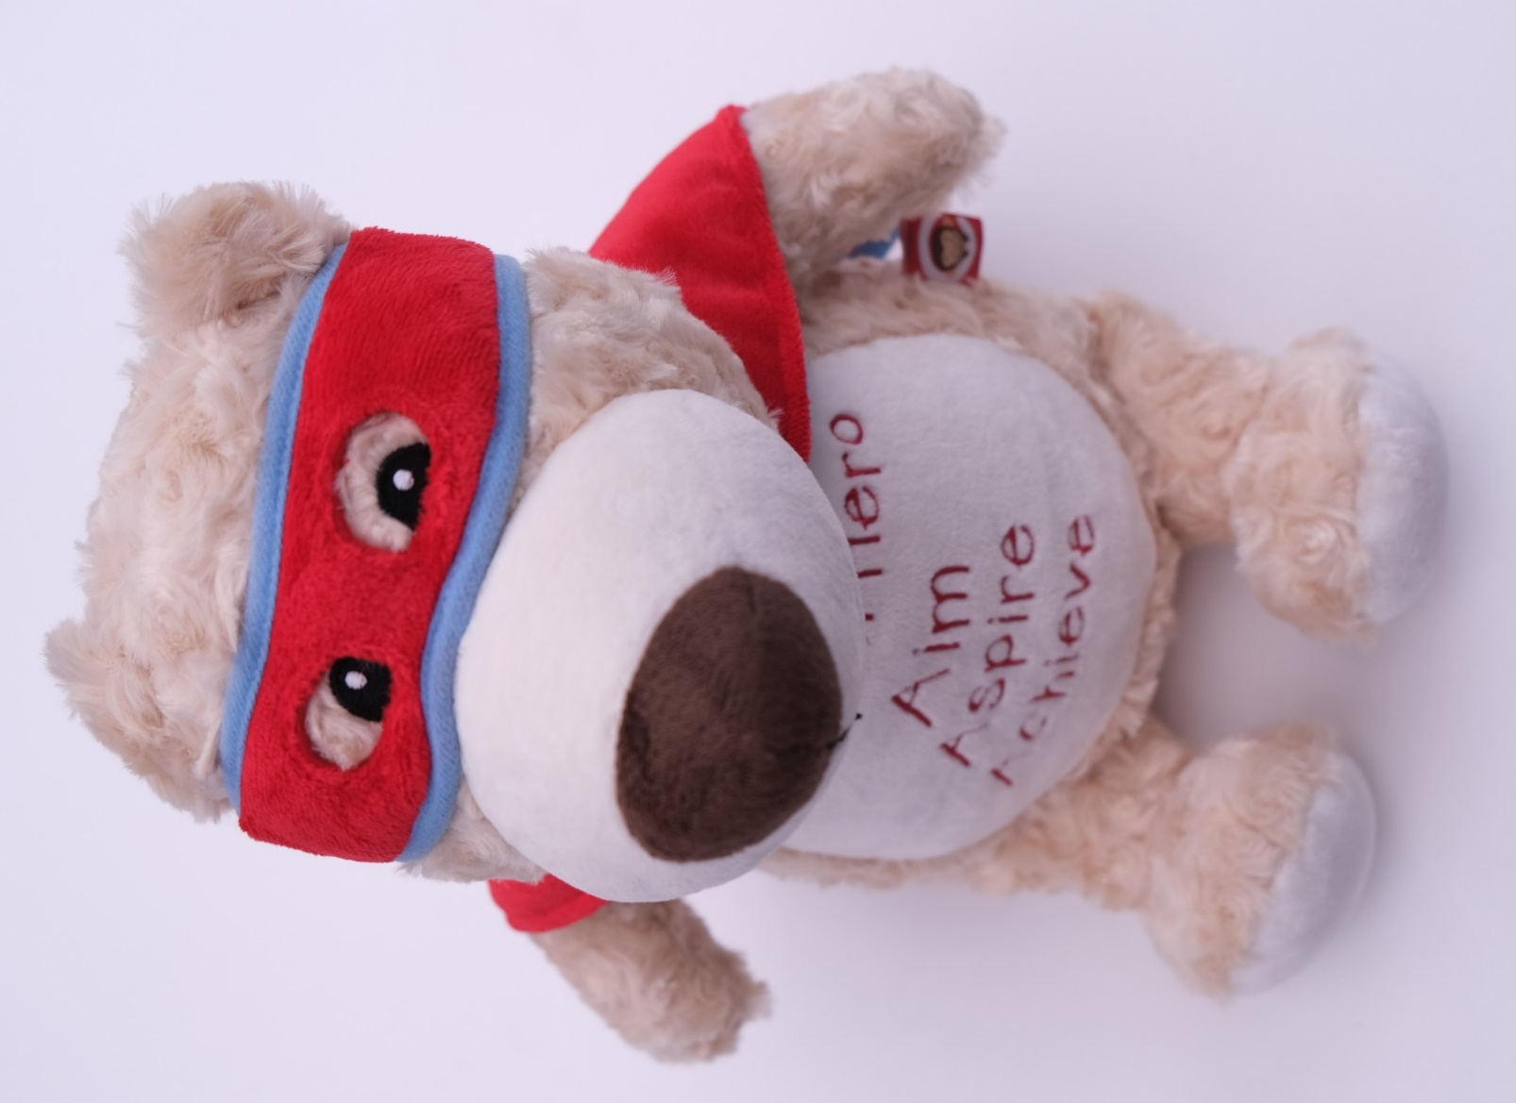
Cubbie our Virtual Hero mascot and our motto ‘Aim, Aspire, Achieve’
Sutton Virtual School welcomes you as we start our educational journey together. We value building strong and purposeful relationships with our families and professionals. We aim to provide the best service to support educational outcomes for our young people.

Introducing the team

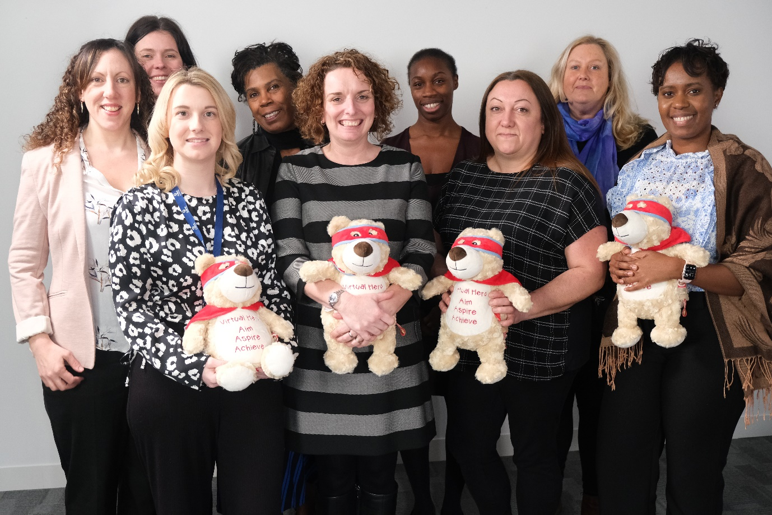

From left to right: Sara Martin, Kate Leyshon, Georgia Doncaster, Beverley Noble, Karen Hopson, Carolyn Ankrah, Donna Spiller, Moira Adams, Sasha-Gay Brown

OUR OFFER

What is Sutton Virtual School?
We are a statutory local authority service responsible for improving educational outcomes for children looked after (CLA). We also support children previously looked after (PCLA) and children with a social worker (CWSW).

We have educational oversight of all Sutton local authority Children Looked After. The age range of children is 2 to 18 years old, and they can live in or out of Sutton. We provide direct support and challenge to professionals working with Sutton CLA. We ensure high aspirations and expectations are in place to support educational achievement.

Mission and values

Our mission is to ensure positive educational outcomes for our children and young people.

Our values are Aspire to be our best, act with Integrity, show Courage and be Kind.

Our motto is Aim, Aspire, Achieve.

Our Sutton Virtual School offer is underpinned by the development of strong relationships with the families and professionals to support the child
High quality education provision  Ensuring prompt admissions to good or better schools | Support and challenge  Ensuring professionals have the support they need and are challenged to provide the best | Aspirations and enrichment  Ensuring young people access a broad education and aim ambitiously high

EDUCATIONAL JOURNEY

Coming into care
When a young person comes into care, Sutton Virtual School will allocate a VS case manager. The case manager will work with the young person, foster carers, the social worker and school. The VS case manager will contact the young person’s school (if they are in education). The first PEP meeting should take place within 20 working days of coming into care.

A Personal Education Plan (PEP) meeting takes place once a term. It ensures educational planning is strong to support the child’s educational journey. The school, social worker and foster carer must attend the PEP meeting. Where possible, the VS case manager will join the meeting too.

ePEP

Sutton Virtual School use an ePEP online system to support the PEP meetings. All the educational information and decision making is recorded within ePEP.

Social workers, foster carers and Designated Teachers access the ePEP system via a login.

Educational transitions

Sutton Virtual School ensures young people are well prepared for educational transitions. This includes:

- moving to a new Key Stage in the same school

- moving to a new Key Stage in a different school/college

- moving to a new school due to a care placement move

- getting ready to leave care either at age 18 or due to end of care status.

We provide support with:

- school / college admissions

- UCAS applications and university finance planning

- SEND admission consultations

- career planning

SUPPORTING EDUCATION AT HOME

Literacy
We value the importance of learning in every aspect of a child’s life experience, not just the classroom. Sutton Virtual School promotes literacy development for all our young people.

We send a Cubbie Bear to all our 2-3 year olds in care. We ask foster carers to read daily with the child and Cubbie to promote education in a fun and positive way. We send out Early Years learning activities to foster homes and invite foster carers to engage the child in these activities, which promote inquisitive thinking and learning through play.

Our statutory primary school-age children receive a Booktrust letterbox package each half term, which contains books and learning games to support their literacy development. In years 7 and 8, young people have the option to receive a book token. This allows them free choice of the book they would like to buy.

Research shows that reading to / with a young person every day impacts educational outcomes. We value foster carer support with reading.

Flashacademy

Any young people who cannot speak a good level of English get access to Flashacademy. an online language learning platform to promote language development. We encourage our ESOL learners to study language skills for 30 mins each day. This helps them learn more words and phrases. They can then access the curriculum and make stronger academic progress.

SEND learning equipment at home

Pupil Premium Plus funding can support the learning of SEND pupils at home. We can supply electronic learning equipment to support communication needs at home. We can provide sensory equipment to support emotional wellbeing and regulation at home.

ADMISSIONS

In-year admissions
Where a young person needs to move school / college, we will help find an appropriate setting. The admissions process differs depending on the local authority so we support the application process to the appropriate local authority.

The foster carer and social worker should complete the admissions application forms. They should also inform Sutton Virtual School of the progress of the application.

End of key stage admissions

Where a young person needs to move school due to an upcoming change in Key Stage, we will ensure early planning. The applications deadline is early January for primary school applications and in October for secondary schools. The process for those applying to special schools can differ.

Most open days at schools take place in October / November in the Autumn term and foster carers should arrange to take the young person to visit the new potential schools. They should discuss the options with social worker and Sutton Virtual School. A final decision is then reached.

EHCP in-year admissions
School admissions is different for children and young people with an EHCP. An in year move to a new school usually happens when a child/young person moves to a different area. The local SEND team will make all applications for prospective schools. They will consult with identified settings. Schools have 15 days to respond to a consultation.

We will work with foster carers and social workers to:
- Use the local authority’s ‘Local Offer’ website to see what schools/colleges may be suitable.
- Consult with a range of setting as many specialist provisions will be full.
- Seek advice from your local Independent/Information Advice & Support Service (IASS).

The new school/college place will be named in the final EHCP.

EHCP end of key stage admissions
When a child/young person with an EHCP moves key stage, this may involve a school move. A transition annual review should take place in the summer term. For example, in Year 5 when planning transition to high school.

The meeting provides an opportunity to discuss the child/young person’s aspirations. Planning to meet needs in the next stage of their education is important. Not all schools can meet the needs of children/young people with SEND. Many specialist provisions have limited spaces. It is advisable to consider a range of prospective settings.

In the autumn term, the SEND Case Manager will begin to consult with prospective settings.

During the spring term, the school place is confirmed. The SEND Case Manager will update the EHCP naming the new school for September. The deadline to issue the final EHCP is 15th February for EYFS, primary and secondary transfers. It is 31st March for transfers to further education.

PERSONAL EDUCATION PLAN

ePEP
Each term, every child looked-after who attends an educational setting has a PEP meeting to discuss educational planning. We use ePEP for all our PEPs. We invite foster carers to contribute to the PEP and be able to access it by visiting the ePEP website (‘click here for first time users’). Once you have completed the initial sign up you will be able to access the young person’s PEPs.

Foster Carer contribution to the PEP

We have created the facility for foster carers to contribute to the PEP meeting in advance. Please access the PEP via your login and click on your young person’s PEP. Please write your views in Foster Carer section.

Sharing with SSW

Sometimes, foster carers wish to share a copy of the PEP with their supervising social worker. This is possible if you click on the young person’s PEP and then click the button in the top left corner ‘View PEP details’. There will then be an option to ‘Print PEP to PDF file’. Here you can download the PEP to your computer and share it with the SSW.

PUPIL PREMIUM PLUS

Funding allocation
The Virtual School Headteacher receives £2410 per year for each statutory school age Child Looked After. There is an allocation of £300 per year for Early Years CLA. Sutton Virtual School makes £300 per year available for post 16 CLA (although there is no Gov funding for this cohort).

Use of funding

The Virtual School Headteacher has discretion to use the Pupil Premium Plus funding. They use PPP to support the development of educational outcomes for Children Looked After. Funding is on a needs basis as required.

Sutton Virtual School works with schools through the PEP process. We establish the best use of the PPP funding based around the child’s individual educational needs. At each statutory school age PEP, there is up to £600 PPP funding available to link to SMART targets on a ‘needs’ basis. Further funding requests can be submitted to the Virtual School Headteacher.

ENRICHMENT

Our vision
We want our young people to have a range of educational experiences to support their academic, social and emotional development. Enrichment can help build skills and self-esteem.

Our programme

We offer a range of activities throughout the year fora range of age groups. The activities on offer will vary from year to year. We have hosted:
- an annual fun day
- a bi-annual writing residential course
- trips to sporting fixtures
- music opportunities
- cultural learning experiences
- interactive science curriculum-based learning

We will contact foster carers with information as appropriate and update our website to show the planned activities over the coming months.

SEND

Children and young people in care are up to four times more likely to have Special Educational Needs and/or Disabilities (SEND) compared to those not in care.

Most children and young people’s SEND can be managed in a mainstream school. The extra support they need is in a SEND Support Plan.
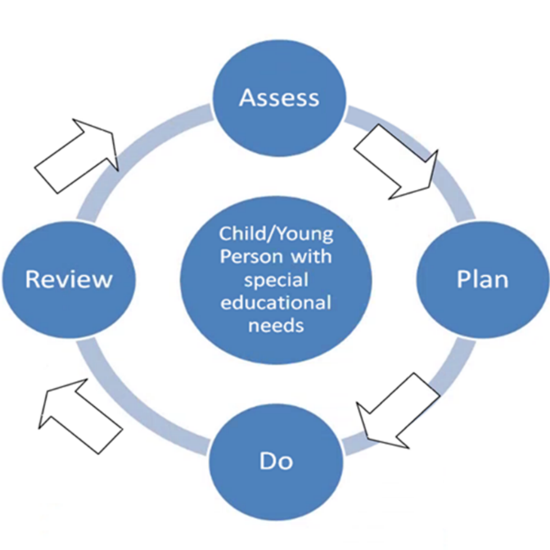

Sometimes, even with extra support in place, a child or young person may require further interventions. The support can go beyond a SEND Support Plan. It may be more appropriate for them to have an Education Health and Care Plan (EHCP).

At this stage, the school, parent/carer or young person can make a request to the local authority for an Education, Health and Care Plan Needs Assessment (EHCNA). Information on how to make a parental request can be found on the Local Offer website.
This is the 20-week EHCNA process:
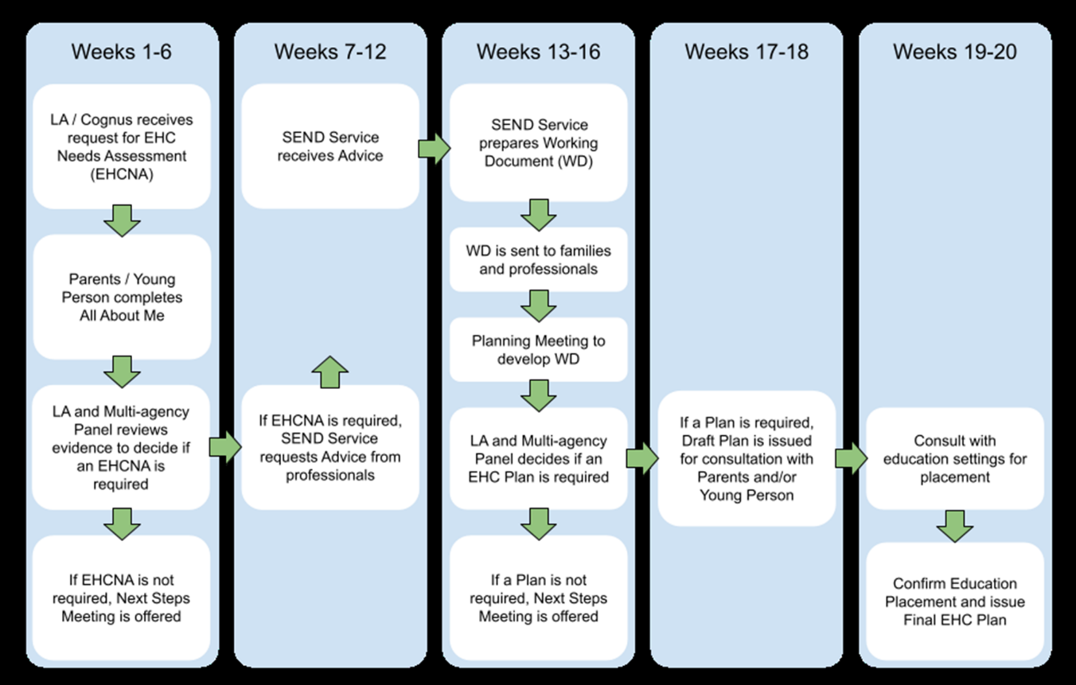

To get more detailed information on the EHCP application process or SEND admissions, please watch our foster carer videos .

