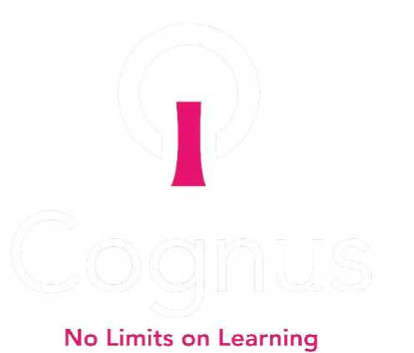

Sutton’s Early Years Foundation Stage
Graduated Response
Nurturing Children and Empowering Our
Educational Settings and Families
Spring 2023

Introduction
Sutton EYFS
Graduated Response
Glossary
1:1
One-to-one
ADHD
Attention Deficit Hyperactivity
Disorder
ASD
Autism Spectrum Disorder
CYP
Child or young person
EAL
English as an Additional
Language
EHCP
Education, Health and Care Plan
EP
Educational Psychologist
EY
Early Years
EYFS
Early Years Foundation Stage
EYGR
Early Years Graduated Response
HI
Hearing Impairment
IEP
Individual Education Plan
LA
Local Authority
MEP
Multi-Element Plan
MLD
Moderate Learning Difficulty
MSI
Multi-sensory Impairment
NC
National Curriculum
OT
Occupational Therapist
PAN
Primary Area of Need
PD
Physical Disability
PMLD
Profound and multiple learning
difficulty
PT
Physiotherapist
PVI
Private, Voluntary or
Independent
QFT
Quality First Teaching
SaLT
Speech and Language Therapist
SEND
Special Educational Needs and
Disabilities
SENCo
Special Educational Needs
Co-ordinator
SLCN
Speech, Language and
Communication Needs
SLD
Severe Learning Difficulty
SPLD
Specific Learning Difficulty
STePS
Specialist Teaching and
Psychology Service
TAF
Team Around the Family
VI
Visual Impairment
SEN
Special Educational Needs
The Graduated Response covers the education and care of all children in Early Years provision, including children with special educational needs and disabilities. https://www.gov.uk/government/publications/early-years-foundation-stage-framework--2

What are Special Educational Needs?
The SEND Code of Practice states that “a child or young person has SEND if they have a learning difficulty or disability which calls for special educational provision to be made for them.
The broad areas of need described in the SEND Code of Practice are:
- Communication and Interaction
- Cognition and Learning
- Social, Emotional and Mental Health
- Sensory and/or physical

Children may have needs in more than one area and that needs may change over time.

The Sutton Early Years Graduated Response (EYGR)
The Sutton Early Years Graduated Response (EYGR) has been written in response to the reforms described in the SEN and Disability Code of Practice: 0-25 years (January 2015). It sets out the procedures and standards that the London Borough of Sutton and Cognus expect to be followed. The Children and Families Act 2014 and the supporting Code of Practice make it very clear that providers must meet the needs of all children and young people with SEND. The approach to meeting the needs of children with SEND is the Graduated Response.
The EYGR provides guidance for Early Years setting SENDCOs, EY Managers, teachers, and practitioners to support them in putting in place appropriate arrangements to meet their obligations in respect to children with special educational needs and disabilities.
In addition to changes in educational settings’ approaches to meeting the needs of children and with SEND and Disabilities, the SEND Code of Practice: 0-25 years (January 2015) sets out reforms for local authorities. These include:
- An increased voice for children and their parents/carers in planning provision at a local authority level.
- A duty to publish information about services for children with special educational needs and disabilities: the ‘local offer’. Sutton's Local Offer - Sutton Council

Early Years Practitioners
Early Years Practitioners are at the heart and essential in adhering to the SEND Code of Practice: 0 -25 years (January 2015) in their settings. The child’s Key Person should retain responsibility for the progress of children with SEND. Where they do have concerns about a child’s progress, their first response should be high quality universal provision, then more targeted provision, or specialist support (as identified in the EYGR Toolkit for Early Years settings.) They will consult with the SENDCo to discuss the most appropriate pathway for the child.

Graduated approach
Identifying potential SEND
On most occasions, progress will be made by children through using the resources and expertise that are already available through universal and inclusive provision in their early years setting e.g., activities in a small group within the setting.

Where a child appears to be below expected levels, or where a child’s progress gives cause for concern, practitioners should consider all the information about the child’s learning and development from within and beyond the setting. This would include formal checks, from practitioner observations and any more detailed assessment of the child’s needs within the setting. Practitioners should consider information on a child’s progress in communication and language, physical development, and personal, social and emotional development.

A delay in learning and development in the early years may or may not indicate that a child has SEND, that is, that they have a learning difficulty or disability that calls for special educational provision.

The SEND Code of Practice 0 – 25 identifies that:
- Providers must have arrangements in place to support children with SEN or disabilities. These arrangements should include a clear approach to identifying and responding to SEN.
- It is particularly important in the early years that there is no delay in making any necessary special educational provision.
- Where a setting identifies a child as having SEN they must work in partnership with parents to establish the support the child needs.
- All settings should adopt a graduated approach with four stages of action: Assess, Plan, Do and Review (APDR).
- The graduated approach should be led and co-ordinated by the setting SENCO working with and supporting individual practitioners in the setting and informed by EYFS materials.

The Assess, Plan, Do, Review Cycle
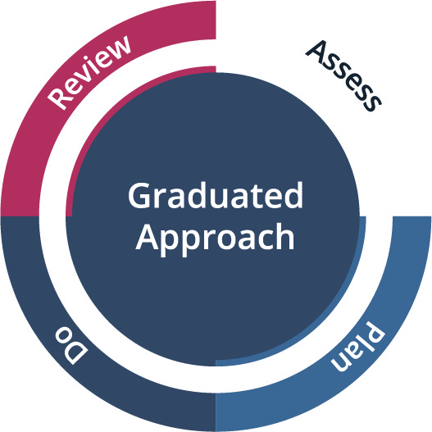
SEND support is provided on a graduated approach and the SEND Code of Practice 0-25 promotes the use of the ‘Assess, Plan, Do, Review’ cycle. This is based upon usual good practice in observation, assessment and planning. This cycle is used to meet the needs of children and improve practice.

Assess
EY Practitioners will work with the child and their family to consider the child’s needs and bring together any relevant information to support the needs of the child.

Plan
Where an approach has been agreed, practitioners, in partnership with the parents, should agree:
- Outcomes that are being sought for the child.
- Interventions and support to be put in place.
- The expected impact on progress and development
- When the next review will take place

Do
The EY setting and the Key Person to the child, will ensure that the identified provision and / or interventions take place.
The SENDCO or other designated adult will assess the child’s response to any provision or interventions, advise and guide practitioners working with the child and be a source of support for any problem-solving.

Review
At an agreed review date, the practitioners working with the child, SENDCO, the child’s parents and with the views and voice of the child, should:
• Assess the progress that the child has made
- Evaluate the impact of the support.
Agreements should be made on:
- Any changes to the outcomes
- Any changes to the type and nature of the provision and support
- Next steps
Following a Graduated Approach is a way to ensure that children’s needs can be met, and further support can be offered if the child does not make the planned progress. The APDR cycle should be applied at each stage of the process. The process is not linear nor does each step operate independently of the steps taken previously.
3. Specialist - Most children who have significant and persistent needs despite appropriate intervention and support will need advice from specialist agencies. This is usually provided at an individual level and will be highly personalised.
2. Targeted- If appropriate, support for children with specific needs including small group and individual targeted interventions, such as language groups.
1.Universal - Most children will respond to simple, reasonable adjustments to meet their identified needs.

Individual Support Stages

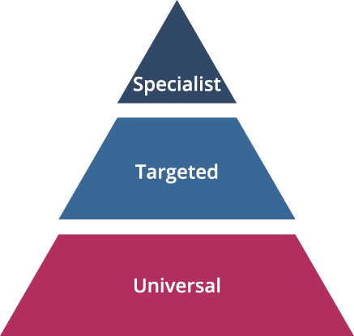

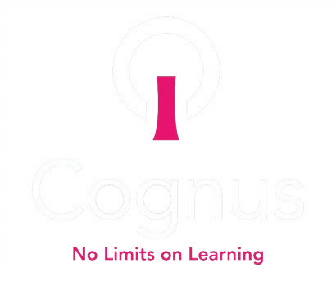
Sutton EYFS
Graduated Response

