Experiencing low mood
Everyone feels low from time to time, it is a normal part of being human. If these feelings continue for a long time, and everyday life feels difficult for someone, they may be experiencing depression.
Symptoms of low mood | Symptoms of depression
- Feeling sad  - Feeling anxious or panicky  - Unable to sleep, or being more tired than usual  - Feeling angry or frustrated  - Experiencing low self-esteem or low confidence | - Low mood that lasts two weeks or more  - Not experiencing any enjoyment from life  - Feeling hopeless  - Not being able to concentrate on everyday things  - Having suicidal thoughts or thoughts about harming yourself

Reference: Get help with low mood, sadness or depression - NHS (www.nhs.uk) NHS 2022
Although it is important to distinguish between the low mood and depression, the content of this sheet is discussing low mood.
Low mood can happen to anyone – it doesn’t discriminate. Sometimes people may experience difficult life events which cause them to feel low, such as losing a loved one, issues in your personal life, family difficulties etc. Although there isn’t always a reason for low mood, potential reasons will vary from person to person, but whatever the reason – the feelings are valid.
The symptoms of low mood can bring about changes in someone’s thoughts, feelings and behaviour. In the cycle of low mood, these will impact each other.
The cycle of low mood:
Feel low
Get less enjoyment from life
Decreased activity
Fatigue and lack of energy

When you stop doing things that make you feel good in life, you feel lower, have less energy and feel more tired. As a result of this, you will do less and miss out on things that you enjoy, continuing the cycle.
Ways to look after yourself if you are experiencing low mood:
- Talk to others. Whether this be family, friends or other trusted people in your life. If you do not feel comfortable talking to the people in your life, there are available helpline services:
- Childline 0800 11 11 (free confidential 24hr helpline for young people who are aged up to 19)
- Samaritans 08457 90 90 90 (free confidential 24-hour helpline)
- Papyrus HOPELineUK 0800 068 41 41 (free confidential helpline for anyone concerned about a young person at risk of harming themselves. Open weekdays 10am – 5pm, 7pm – 10pm; weekends 2pm – 5pm)
- SHOUT: text ‘SHOUT’ to 85258. Anonymous text support.
- Kooth www.kooth.com (a website offering free, anonymous, online counselling and peer support services 24/7, 365 days a week)

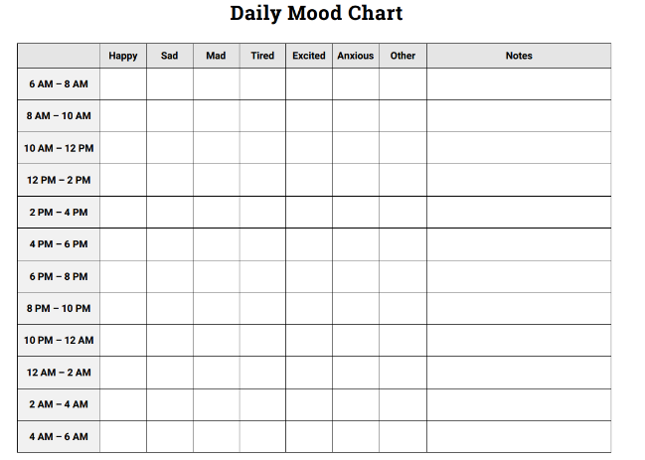

- Keep track of how you are feeling throughout times in the day. By identifying how certain activities make you feel, it can help to consider what you need more of in your life to receive the ‘feel good factor’ from life.

- Being more active will help you to feel less tired and lethargic, helping to feel more positive in mood:
Feel more positive and hopeful

Get more enjoyment from life
More energy

Increased activity

If you find yourself feeling low, it is important to ask yourself: what activities make me feel like my best self?
If low mood lasts longer than a few weeks and you or someone you know is finding it hard to cope, please contact your school pastoral/mental health team.
Please contact the Cognus Educational Psychology Service for more information.

