Anxiety and emotional regulation

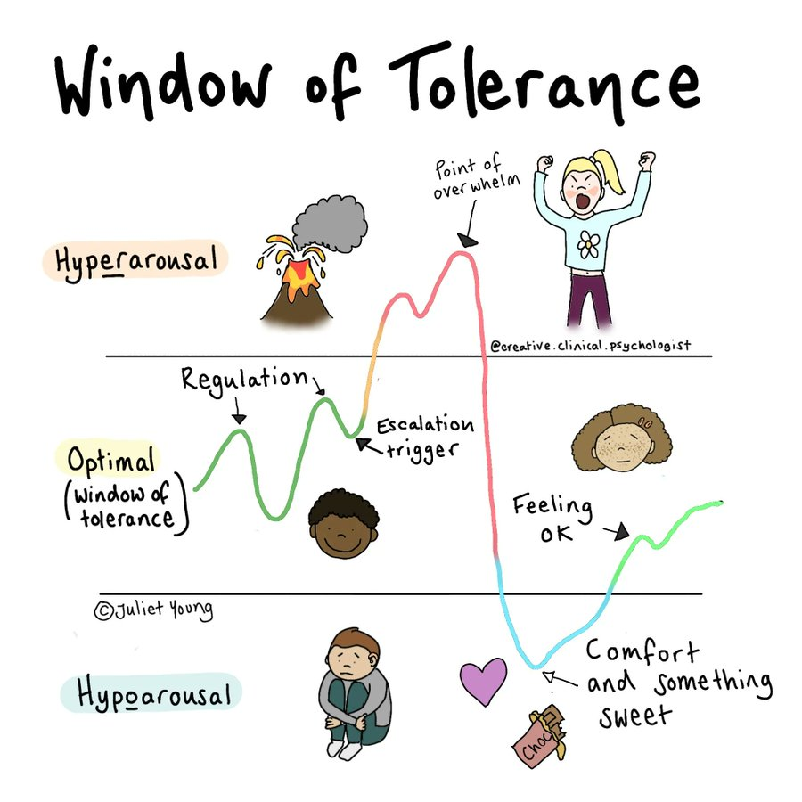
Everyone has a window of tolerance: your own unique window where you feel safe, respond to challenges, cope with adversity and take risks.
If you experience repeated stress, your window of tolerance will get smaller. What others may perceive as small, minor events may feel stressful and overwhelming for someone that has experienced a lot of stress. You may respond with extreme reactions to events, whereas others may not respond much at all.
Normal, everyday things like changing from one classroom to the next or a friend asking to rearrange plans you had may take you out of your window of tolerance. It can feel like your alarm system is constantly alert, looking for the next sign of danger.

Dan Siegel’s hand brain model shows us what happens when we enter fight/flight/freeze. When we have ‘flipped our lids’ different parts of our brain are not integrated, meaning it is harder to learn, problem-solve and communicate. A very helpful video to watch: Flipping Your Lid & Getting Back in Control- The Connect - YouTube

How we can regulate ourselves when feeling anxious:
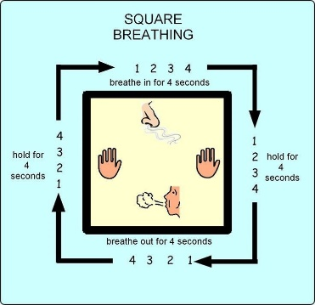
A common physical symptom of anxiety is fast and shallow breathing. To reduce this, breathing strategies are useful to return to a normal rhythm. One way of doing this is using squared breathing:
Other breathing techniques: Breathing techniques - YouTube
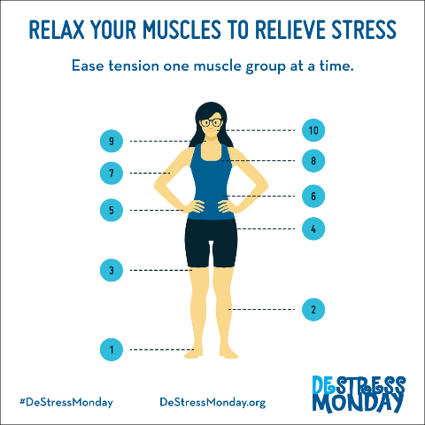

Muscle relaxation is a way to release the tenseness that our body creates when we feel anxious.
Healthy Minds Lincolnshire- Progressive Muscle Relaxation (youtube.com)

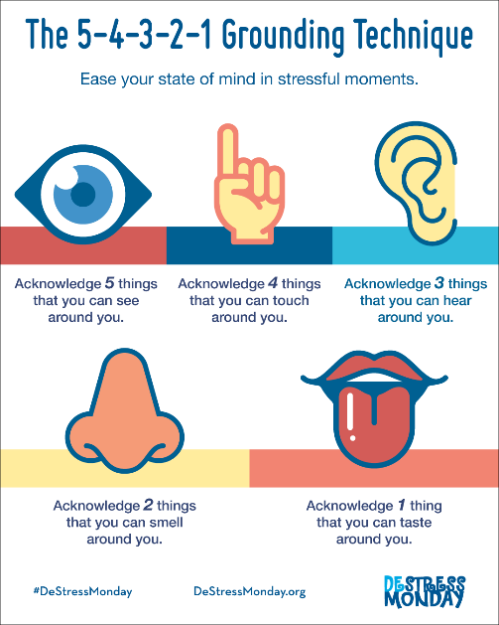

When experiencing anxiety and stress, we can often be in our thoughts and not aware of what is around us. One way to come back to the present moment is using a grounding technique called 54321, involving focusing on the senses.

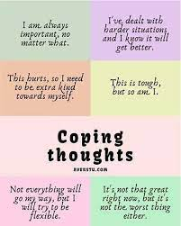

Another element of anxiety is unhelpful thoughts. Our thoughts can often contribute to lower confidence and self-esteem. One way of trying to change this is developing positive coping thoughts, to remind ourselves of when our unhelpful thoughts surface.

Another idea is to create a self-soothe box.
Self-soothe boxes can be created in the form of a spare pencil case. They will use items that are soothing for the senses, helping to calm you down in any situation. Examples of items that can go inside are:
Olfactory/smell: your favourite smell, lavender drops on a tissue, vanilla, camomile etc – it must be personal to you.
Touch/concentration: hairbands to flick on wrist, bubble wrap, velvet, poppits, small fidget toys, rubiks cube, pens/pencils to colour in.
Visual: photos/memories that are important to you, such photos/images of future motivations that will inspire you.
Taste: chewing gum, peppermints, sucking sweets.
Further information: How to Make a Self-Soothe Box | Young Person Blog | YoungMinds

If anxiety feels like it is becoming overwhelming and you or someone you know is finding it hard to cope, please contact your school pastoral/mental health team.
Please contact the Cognus Educational Psychology Service for more information.

