Trauma informed practice:

Guidance document for professionals

Contents
Introduction to trauma 2
What do we mean by trauma? 2
Why do we need trauma-informed schools? 2
The impact of trauma for children and young people 4
How does trauma impact on early brain development: 4
How does trauma impact on learning? 5
How does trauma impact emotional regulation? 7
How do trauma responses present in school? 8
Embedding trauma informed practice at a whole school level 10
Whole school trauma-informed approaches that can make a difference, based on the Attachment Research Centre (ARC) framework: 11
Build a sense of safety: 12
Transitions: 12
Choices: 12
Interactions: 13
14
Emotion Coaching: 14
Reacting to behaviour: 14
The three Rs: 15
Restorative conversations 17
Practical next steps 18
Signposting 19
Recommended reading: 19
Document references: 20
Appendices 21

Introduction to trauma
Developed in collaboration with Sutton Virtual School and Cognus Educational Psychology services, this guidance is to support staff members in schools with a brief explanation of psychological models of trauma. This guidance should be used to embed trauma-informed practice into interactions with young people in education.
This document can be used to complement the Nurture Guidance created by Cognus Educational Psychology Service: Sutton nurture guidance (cognus.org.uk)
For further advice and guidance, professionals can seek support from the Sutton Virtual School and Educational Psychology Service.

What do we mean by trauma?
The UK Trauma Council defines trauma as: 'a distressing event or events that are so extreme or intense that they overwhelm a person's ability to cope, resulting in lasting negative impact.'
Research shows one in three children and young people are exposed to at least one potentially traumatic event by the time they turn 18. To help school become a safe place for children, this statistic highlights the need for a trauma-informed care approach within schools.

Why do we need trauma-informed schools?
Adverse Childhood Experiences (ACEs) are highly stressful, potentially traumatic events or situations that occur in childhood and adolescence. The experiences directly impact the child and their environment.
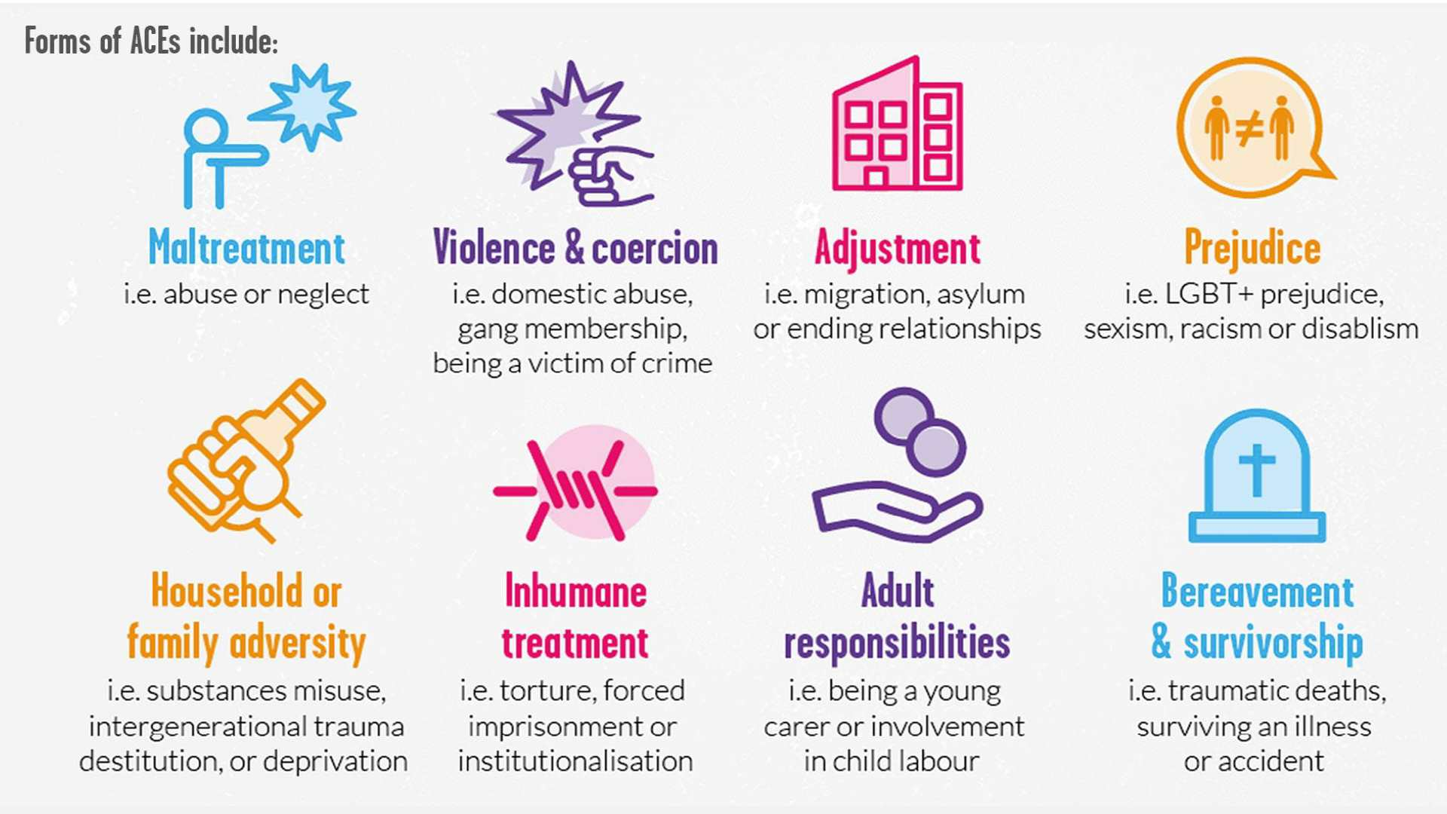
*Source: Young Minds
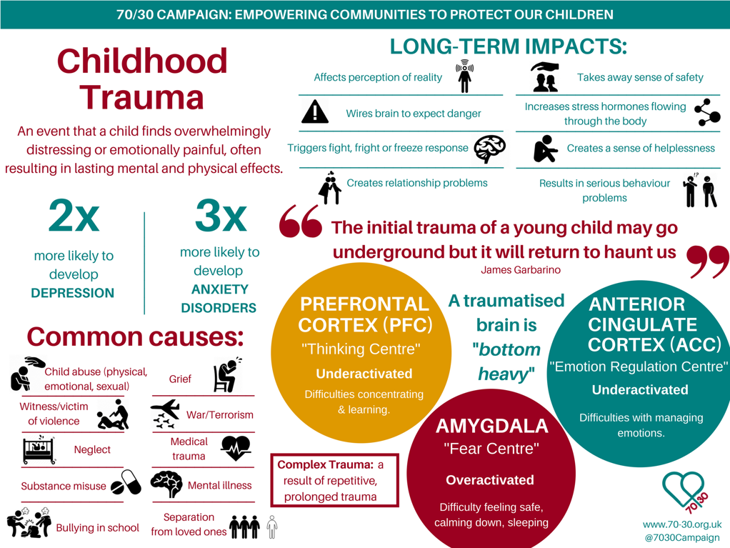

As shown in the above graphic from the 70-30 campaign, there are several implications and long-term impacts of ACEs. Experiencing chronic stress can impact on brain development and contribute to mental health and physical health difficulties later in life. Children and young people that experience ACEs need support from adults that understand their behaviour is not their fault, but a form of communication based on trauma they have endured.
Children spend over 15,000 hours at school – much of their formative years. Education environments have a huge impact on younger generations development, it is important staff have the knowledge and skills to support children that have experienced ACEs.

The impact of trauma for children and young people

How does trauma impact on early brain development:
Stress is a normal reaction that can be good for us. When we can regulate stress we experience, it enables us to function at our best. When we cannot regulate stress, we receive more of the stress hormone that is toxic to the brain.
Early experiences shape how our brain is built. A strong foundation increases the chances of positive health and learning, while a weaker, less secure foundation increases the possibility of more negative outcomes. Having negative experiences does not mean a child will have a fixed path – there are always opportunities to support and strengthen a child’s brain. Positive experiences and interactions contribute to this.
The brain develops from the bottom up, and the brain stem develops first. The brain stem is responsible for keeping us safe; it is the part of the brain that makes us run away from danger, fight for our life or freeze inside. It keeps us alive.
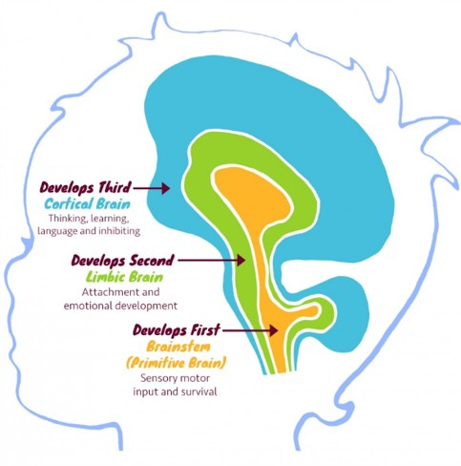
If there is stress during pregnancy, a child will be born with an over-sensitive stress response. The brain stem is always firing, like a fire alarm that is faulty – going off when there is no smoke. This is helpful for a child living in a dangerous environment – the brainstem is constantly on high alert, ready to keep them safe and prevent danger. However, when placed in an ordinary, low-stress environment, it can be difficult to adapt – a child will be in a constant state of fight, flight or freeze – searching for danger everywhere.
The middle part of the brain is the limbic system and continues to grow over the first 18 months. The focus is developing attachment, relationships and regulating emotions. The amygdala is an area of the brain vital for processing emotions. It activates the fight/flight/freeze response – when children experience chronic and toxic stress, the amygdala becomes overactive. When the brain is consistently on high alert for threats, there becomes a heightened stress response and increased anxiety. When children are always heightened, it takes a lot to feel safe and secure, especially in relationships with other adults.
The top part of the brain is called the cortical brain. This continues growing into late twenties. This is the part of the brain where academic learning takes place. The focus is on cognitive functioning, reasoning, and reflecting.
If correct development doesn’t take place in the first two brain regions, children will find it difficult to learn in a school environment as they are developmentally stuck in the brainstem. Whilst they are stuck here, they cannot form secure attachments; manage their emotions or behaviour; think, learn, or reflect because they are simply trying to stay alive in a world that they feel is highly dangerous.

How does trauma impact on learning?

Heather Geddes introduced the learning triangle summarizes the triangular relationship dynamic between the pupil, the teacher and the learning task and helps us to recognise differing patterns of pupil response and engagement in the task and so to identify the possibilities for intervention.
In any learning experience, there is a triangle between teacher, pupil and task. In order to learn, the pupil needs to feel secure and trust the relationship with the adult. However, he or she also needs to be able to separate from the adult and work on the task, secure in the knowledge that the adult is available to provide help and support when required.
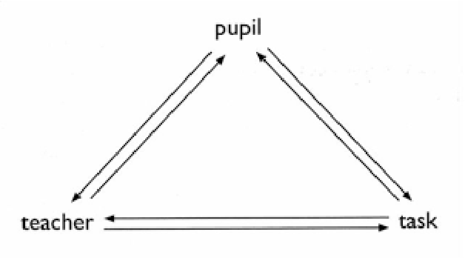
For example, some pupils may be over-anxious about maintaining and checking out the relationship with the adult, continually seeking her reassurance and attention, and unable to focus on any learning task which might distract them from this focus. These pupils may not have had any experience of a primary caregiver thinking about them and holding them in mind when they are absent.
In contrast other children may be unable to trust the relationship with their teacher: they have learned in their early years that they might be rejected in their attempts to seek attachment. The relationship is perceived as dangerous. These children will only be able to focus on the task, refusing to interact and accept help or teaching when needed.
Executive functioning
Executive functions are made up of interrelated cognitive processes involved in goal-directed thought and action that help you to carry out or execute a task (Baggetta & Alexander, 2016). They are associated with the brain’s frontal lobe and prefrontal cortex (Miyake et al. 2000).
Described as the conductor of the brain’s orchestra (person at the front organising all the different instruments, telling them when to start and stop and helping them to interact with each other. They help with regulation of thoughts, feelings and behaviours (cognitive regulation, behavioural regulation and emotional regulation).
Response inhibition | Working memory | Emotional control
Task initiation | Flexibility | Sustained attention
Planning and prioritising | Organisation | Time management
Metacognition |  | Goal-directed persistence

We are not born with executive functioning skills – we are born with the capacity to develop them.
For children that have experienced trauma in their early lives, their stress response is activated easily. When they are in fight/flight/freeze mode, it is hard to problem solve, plan or process information. Just like the bottom-up model of the brain, it is hard for children and young people to activate their cortical brain.

According to the National Child Traumatic Stress Network, exposure to trauma can:
- Impact attention, memory and cognition
- Reduce a child’s ability to focus, organise and process information
- Interfere with problem solving and planning
How can adults help?
Time management in class | EF difficulties examples | Strategies
 | - Spending too long on one question in an exam.  - Having enough time to proof read.  - Finish the task when needed. | - Set a timer.  - Have reminders.  - Work in 5-minute bursts.

Goal directedness | EF difficulties examples | Strategies
 | - Using new technology.  - Making multiple drafts of a text.  - Proof reading.  - Only trying once. | - Chunking big tasks.  - Work with a partner.  - Create a goal and make steps to achieve it.

To help children and young people, the process of plan, do, review can support pupils during a task. Students will monitor progress as they go, identifying strategies to support them. Reviewing is a key part of the process.
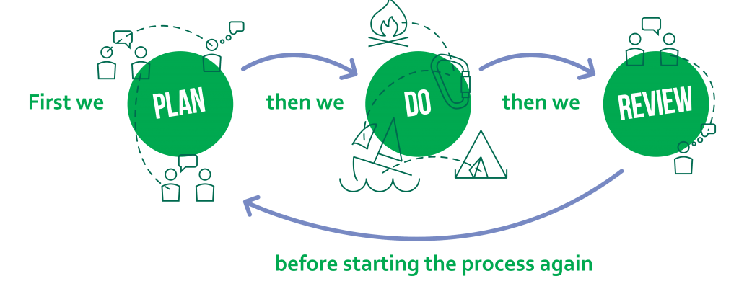

To further understand the impact of trauma on executive functioning and how to support young people, please watch the trauma and executive functioning series on the Cognus website:
Trauma & Executive Function Series – Cognus

How does trauma impact emotional regulation?

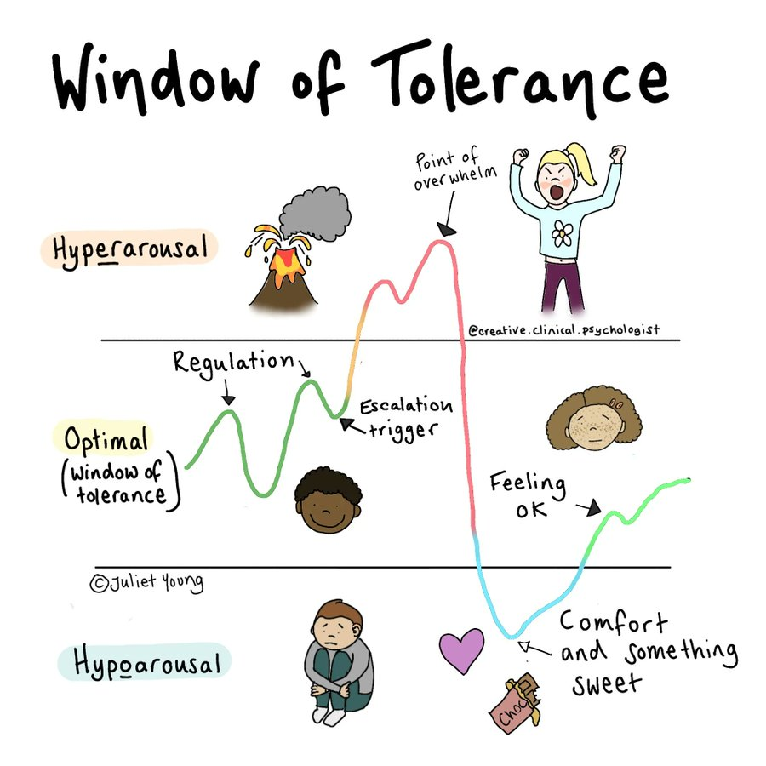
Everyone has a window of tolerance: their own unique window where they feel safe, respond to challenges, cope with adversity and take risks.
Repeated experience of toxic stress leads to a shrinking of this window of tolerance. Children who’s social engagement hasn’t been met by caregivers are hardwired to enter fight/flight/freeze a lot quicker as a survival strategy. As they grow older their window of stress tolerance has become much narrower as a result so they may respond with extreme reactions to events which others might perceive as relatively minor.
For children that have experienced trauma, small ‘every day’ things (like a change of one classroom to the next) spirals them out of their window of tolerance. You can expect traumatised children to be over or under aroused for most of the time and, in either state, their behaviour is out of their hands; they simply cannot control it no matter how hard they try. Their alarm system is constantly on, looking for the next sign of danger.
Dan Siegel’s hand brain model shows us what happens when the lower parts of our brains take over (fight/flight/freeze). When we have ‘flipped our lids’ different parts of our brain are not integrated, meaning it is harder to learn, problem-solve and communicate. A very helpful video to watch: Flipping Your Lid & Getting Back in Control- The Connect - YouTube

How do trauma responses present in school?
Children that have experienced trauma in their lives will understandably behave differently to children who have not experienced any trauma.
It is important to think about the developmental stage children that have experienced trauma are stuck in. Babies and toddlers are instinctively controlling of their parental figures in order to survive – it is unconscious. When these needs have been met (consistently and predictably), children’s need for control will gradually decrease, building on being able to meet their own needs.
If children and young people have not had their needs met early in life, they will be naturally and understandably be fighting to have control as they get older. If individuals have experienced neglect or abuse, they will have developed behaviour responses to achieve responses from parents/caregivers. From a secure attachment lens, these can be perceived as negative, controlling or challenging. It is important to consider these behaviours through a trauma-informed lens, trying to unpick where this behaviour stems from:
“They are manipulating”:
What if… The child is using behaviours which have helped them to be noticed or to survive in another environment?
“They have no respect for authority”:
What if… What if … the child has experienced a lack of respect and dignity in past relationships? They need to learn to trust you – adults may have let them down in the past.
“Praise and rewards never seem to work”:
What if… praise is too abstract for a child whose developmental age is younger? What if the child feels shame about failing to earn a reward, or is worried that if they receive one, positive attention will stop?
These behaviours can often make it difficult to create and maintain friendships, which can lead to children continuing to feel frustration, shame and create a negative sense of self, perpetuating the notion they are not worthy of having friends.
When children go outside of their window of tolerance, their behaviour can appear negative. It is important to remember a lot of the time this is a survival strategy, trying to stay safe in a world they have learned is unsafe. In a classroom and school, this can look like:

Fight: self-preservation at all costs  - Explosive temper and outbursts  - Aggressive, angry ​  - Controlling of others ​  - Bullying ​  - Can’t hear others points of view  - Demands perfection from others ​  - Might look like conduct disorder ​ | Flight  - Feelings of panic and anxiety ​  - Rushing around ​  - Can’t sit still or relax ​  - Obsessive and or compulsive behaviour​  - A need to control small elements of situations  - Needs things to be perfect  - Might be confused with ADHD, OCD, anxiety ​
Freeze  - Spacing out, disassociation – brain fog  - Hiding  - Difficulty making decisions ​  - Not accepting achievements ​  - Isolating self | Fawn  - People pleasing  - Scared to confront, over caring
​

Embedding trauma informed practice at a whole school level
Definition of Trauma-Informed practice from the Department of Health and Social Care (2022):
Trauma-informed practice is an approach to health and care interventions which is grounded in the understanding that trauma exposure can impact an individual’s neurological, biological, psychological and social development.
Being trauma informed requires a consistent approach, sensitivity and individual self-awareness when working with young people that have experienced adverse childhood experiences.
To begin to view interactions and relationships through a trauma informed lens, an important starting point is asking the question of “what happened to you” instead of “what is wrong with you?”
When working with children that have experienced trauma, their behaviour needs to be viewed as the child’s attempt to manage or cope; they are trying to stay safe in a world they have been taught is unsafe.
It is important to note that trauma is not the same for everyone, individuals will experience it very differently. What works for one child will not work for another, so it is important to adapt your approach depending on individual needs. In such situations, the graduated response is a helpful tool to use:
Stage one | Universal support | Advance planning and assessment, home/school development, specialist in school support.
Stage two | Outreach | Advanced planning and assessment, outreach interventions.
Stage three | Extended outreach | Advanced planning and adjustments, engaging with other educational providers.

For more information on each stage and how to implement this, please see the latest 2023 Cognus guidance: Sutton’s Graduated Response – Cognus

Whole school trauma-informed approaches that can make a difference, based on the Attachment Research Centre (ARC) framework:
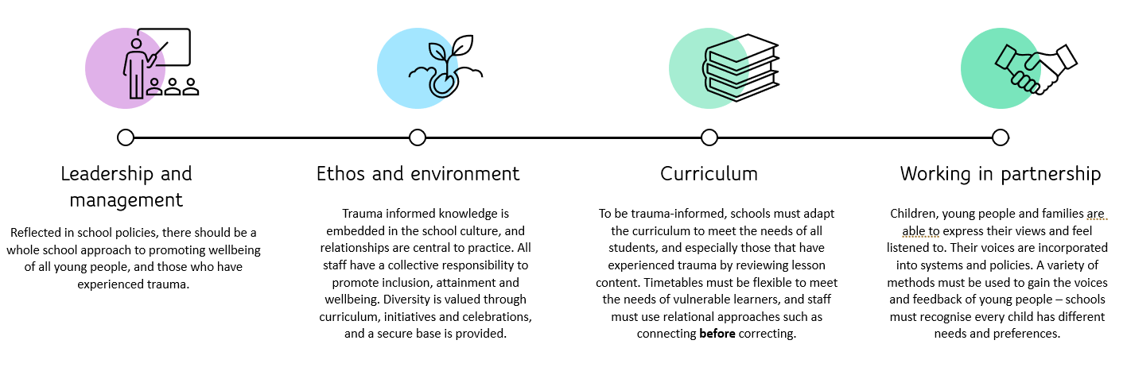
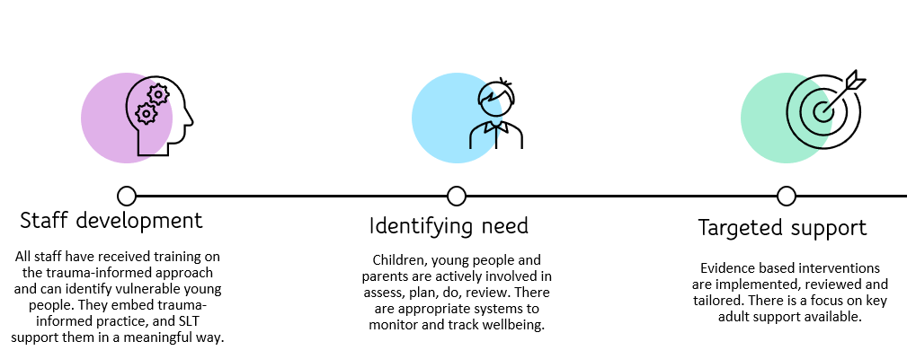

To start understanding the nurture provision of your school, please see appendix 1 for a self-evaluation toolkit.
To further evaluate the extent of trauma-informed practice in your school environment, please complete an audit based on the ARC framework: The ARC Pathway | ARC (the-arc.org.uk)

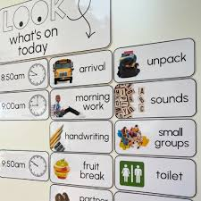
There are a few approaches you can build into your everyday interactions with children to support a trauma-informed approach:

Build a sense of safety:
Create a structured setting, use visual routines and direct children to them. Create predictable routines where children know what will happen and when, as much as possible.

Warn children if you are going to do something different, for example turning down the lights, making a loud noise or playing a video on the screen. These things that may seem like small changes may be a trigger for a trauma response, which could result in unsafe behaviour.
Review material for lessons beforehand - consider if any is used to shock or disturb students. Develop warnings so students know what to expect, and to step out if they want to.
Follow through on promises, keep your word. If there are changes in the day, allow time for a key adult to relay this information to the children.

Transitions:
Transitions need to be managed carefully. Whether this be to different classrooms, assemblies or back from lunch/breaks at school, or changes in the day at the weekend/half term. Have a consistent plan in place, discuss what children are finding tricky about these specific times and create a plan with them with the aim of a feeling of safety.

Choices:
Experiencing trauma often means experiencing a lack of control. When appropriate, by providing children with choice or control over something can help them to feel safer in their environment and reduce anxiety.

Interactions:
To support these children, it is important to embed a few techniques in your interactions. We want to listen without judgement, show genuine interest, we want to show them that we have unconditional positive regard for them. These children may be wary of adults, it will take time and commitment to show them that you care. Models such as PACE and emotion coaching can support this – see appendix for further details.
One model created by Dan Hughes that has been tried and tested, supporting young people with experience of trauma is PACE:
Playfulness: using a playful, light-hearted tone creates a lighter atmosphere, rather than lecturing or appearing irritated. It helps children to become less defensive or withdrawn. It can help reduce tense situations.
Acceptance: with this, you are unconditionally accepting the child’s inner life. It does not imply accepting behaviours that may occur, rather accepting the motive for the behaviour. There will still be logical consequences if hurtful or harmful behaviour occurs, however, acceptance communicates to the child that their inner self isn’t being criticised.
Curiosity: being curious without judgement lets children know that adults are trying to understand what is going on for them. They often don’t know why they behave a certain way; curiosity helps children to understand their inner world, they can open up to the adult without feeling criticised or judged. This can lead to less defensiveness, shame and guilt whilst understanding themselves and their behaviour more than before.
Empathy: this shows the child that the adult understands the child’s inner life is important, and they want to be there to support them through the difficulty. The adult demonstrates that they know this is a difficult experience for the child, and they do not have to go through it alone.
Examples for a child experiencing separation anxiety:
Playfulness:  “I think Mr Teddy Bear is getting a little bit cold outside!”  “I think we might both turn into statues if we stay outside in this cold!” | Acceptance:  “It feels really difficult to leave Nan and come into class this morning. I understand how much you miss her and worry about her in the day at school.”  “I understand it must feel scary to let mum go home and come into school, it’s a frightening thought to think she won’t be here this afternoon.”
Curiosity:  “I’m wondering if you are scared to come into school this morning because…”  “I wonder if something happened this morning to make you feel upset before coming into school, and now it feels difficult to come inside?” | Empathy:  “I know there is a lot going on at home right now, and it feels hard to come into school because you are worried. It feels really difficult to be worried all the time.”  “I understand you have a lot going on inside of your head right now. It feels like there is a weight on your shoulders and you can’t let it go. I can see how difficult it is for you to come inside this morning.”
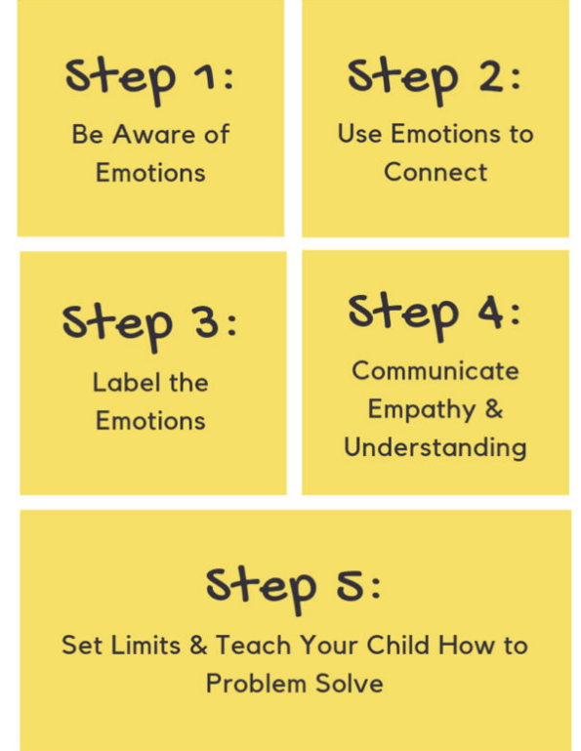

Emotion Coaching:

An approach to communicating with children and young people when they are experiencing strong emotions (e.g. anger, distress, worry), which helps them to get better at managing these strong emotions for themselves over time.
Emotion Coaching involves adults using a communication style of high empathy (trying to understand how the child is feeling) and high guidance (helping them to think about how they can manage their feelings next time). Siegel (2010) suggests that when a person 'flips their lid', this is the best time to teach them about their emotions.

Reacting to behaviour:
It can feel difficult in the moment responding to challenging behaviour. By reminding yourself that the student’s behaviour is communicating a need, you can think about responding in a non-retaliating manner. Be aware of your body language and tone. We want to avoid arguing – we are the adults, it is essential we are regulated ourselves and set an example before responding.

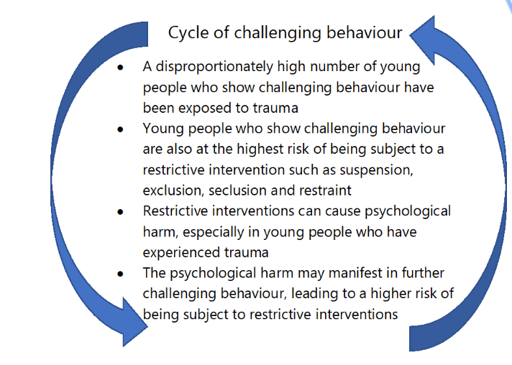

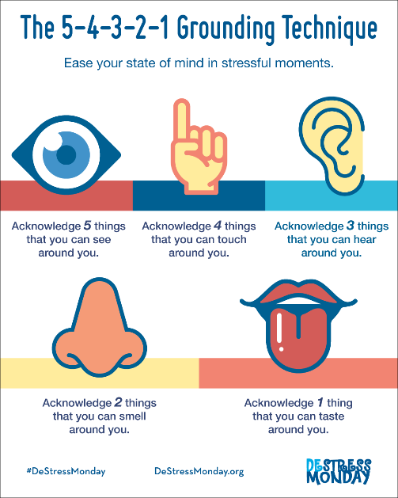

This is an example of a grounding technique that can be used. By focusing on the senses, rather than responding to behaviour in the moment, we can respond in a healthier and more attuned way to children.

If it is possible to take some space and ask another adult to briefly take over or try to create some space in the environment. It is important to let the child know you still have them in mind, and you are ready to interact when they have calmed down.

The three Rs:
Sometimes students can be described as going from ‘0-100’. From an outside perspective, it may look like there was no trigger for explosive behaviour. However, research shows that individuals exposed to prolonged stress, their stress response is always on. They are acting and behaving from a place of survival – they may be in fight, flight or freeze mode.
When the stress response is on, students are most likely not going to be ready to learn. They won’t be able to focus, they need to be able to regulate their nervous system before they can engage the areas of the brain needed to learn.
Dr Bruce Perry created a simple but very powerful model to show how to re-engage individuals in survival model:
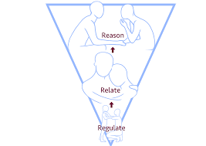
- Regulate: To help them to feel calm and soothed, individuals need to complete repetitive, soothing activities. This can look like:
- Deep breathing
- Being in a sensory area
- Going for a movement break/walk
- Drawing

One idea to help students have a toolkit for this is to help them create a self-soothe box: How to Make a Self-Soothe Box | Young Person Blog | YoungMinds
Self-soothe boxes can be created in the form of a spare pencil case. They will use items that are soothing for the senses, helping to calm students in the classroom/outside of it. Examples of items that can go inside are:
Olfactory/smell: their favourite smell, lavender drops on a tissue, vanilla, camomile etc – must be personal to the young person.
Touch/concentration: hairbands to flick on wrist, bubble wrap, velvet, poppits, small fidget toys, rubiks cube, pens/pencils to colour in
Visual: photos/memories that are important to them (but not to further dysregulate), photos/images of future motivations that will inspire them
Taste: chewing gum, peppermints, sucking sweets
- Relate: Once children are in a calmer state and feel regulated, they need to feel understood and supported. Staff may need to stay physically distant but emotionally close. We may want to talk and reason, but they might not be ready for that yet.
Ways of relating can be through non-verbal communication:
- Eye contact
- Non-verbal mirroring
- Active listening
If they are ready to talk, we can relate to the students by validating their experience. Using PACE or emotion coaching can be helpful:
I can understand why not getting a turn before the bell went for break was frustrating for you.”

“You seem to be upset, I wonder if that is how you’re feeling right now?”

3: Reason: Once students are regulated, calm and have been able to form a trusting relationship from the situation can they access their thinking and reasoning part of the brain. This is where restorative conversations can happen.
Advice on how to use restorative conversations with students can be found in the appendix.
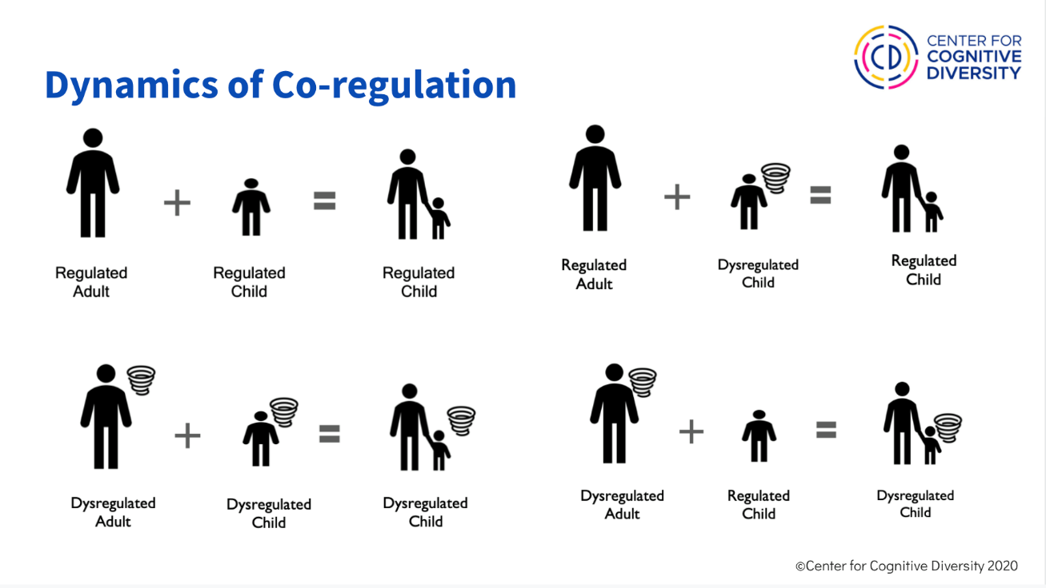

As staff members, we recognise your patience and resilience may take a toll. If we are outside of our window of tolerance, it will impact how we react to students and potentially escalate a behaviour situation. This image shows a regulated adult can help regulate a child that is dysregulated. But when both are dysregulated, coming back down to the window of tolerance is not possible.

Restorative conversations
When children are dysregulated, they do not have access to their prefrontal cortex: the part of the brain that allows the use of reason and logic. Restorative conversations regarding behaviour must only take place once the child (and adult) are regulated and calm.
Restorative conversations can help to reframe behaviour. They can help a child consider what can be different next time, and they can reinforce the knowledge that children will start the next lesson as a clean slate without any judgement or resentment. This lets them know that relationships will always be repaired.
Please see appendix for Cognus guidance on how to use restorative conversations.

Practical next steps

To embed these principles and become more trauma-informed, there are a few practical steps your setting can take:
- Create a self-evaluation of your school, using a tool such as the ARC audit.
- Nominate a staff member to take the lead in embedding trauma-informed practice.
- Set up a meeting with key staff such as safeguarding leads, SENCOs, and designated teachers to develop an action plan.
- Deliver training to ALL staff at the school that interact with children, allowing everyone to gain knowledge of the trauma-informed approach and how to implement it in their role.
- Review the interventions on offer and their current impact.

Signposting

Organisation | Support | Contact details
Sutton Virtual School | Advice and support for professionals | Advice and Support for Professionals – Cognus
 | Resources | Resources – Cognus
Sutton Virtual School and Cognus Educational Psychology Service | Weekly consultations running every Thursday. Slots are available for schools to discuss a student with a social worker. | Book a consultation – Cognus
Cognus Educational Psychology Service |  | Educational Psychology – Cognus

Recommended reading:
Louise Bomber:
- Inside I’m hurting (2007)
- Know how to teach me (2020)
- Working with relational trauma in schools (2020)
Bessel Van Der Kolk:
- The body keeps the score (2014)
Jen Alexander:
- Building trauma-sensitive schools: Your guide to creating safe, supportive learning environments for all students (2019)

Document references:

Complex Trauma | The National Child Traumatic Stress Network (nctsn.org)

Flipping Your Lid & Getting Back in Control- The Connect - YouTube
- A helpful video explaining brain development and ‘flipping your lid’)
How to Make a Self-Soothe Box | Young Person Blog | YoungMinds#
- A helpful self-regulating tool that children and young people can use anywhere

https://uktraumacouncil.org/
- Helpful resources, videos and training opportunities

Neurosequential model of therapeutics in a therapeutic preschool: Implications for work with children with complex neuropsychiatric problems. (apa.org)

P.A.C.E. (danielhughes.org)
- A model to promote a relational approach
Sutton’s Graduated Response – Cognus
- Helpful information for schools when considering levels of support for students
The ARC Pathway | ARC (the-arc.org.uk)
- An audit tool for schools to help evaluate their trauma-informed and relational practice
The Three R's (beaconhouse.org.uk)
- A model created to support the bottom-up approach, and supporting individuals that are dysregulated

Trauma & Executive Function Series – Cognus
- Helpful videos
Understanding and Working with the Window of Tolerance - ATTACHMENT AND TRAUMA TREATMENT CENTRE FOR HEALING (ATTCH) (attachment-and-trauma-treatment-centre-for-healing.com)

Understanding trauma and adversity | Resources | YoungMinds

Working definition of trauma-informed practice - GOV.UK (www.gov.uk)

Appendices
Appendix 1:
Self-evaluation checklist:

Nurturing school self-evaluation sheet
Rate your setting on each of the scales below, where D = developing, S-secure and E = excelling
No | Standard | Rating and evidence
1 | The head, staff and governing body actively promote personal, social and emotional wellbeing for all children and adults involved in the school.
2 | There is a positive behaviour policy with the emphasis on ‘d0’o not ‘don’t’ and on making choices and understanding the consequences.
3 | There is an understanding that children need to develop their social and emotional competence that will help them understand the rules that govern relationships between people. The school actively introduces experiences and activities to help children cope with difficulties and form positive relationships.
4 | The school has positive home-school partnerships
5 | Everyone is made to feel welcome.
6 | The school seeks to involve all its members in decision making.
7 | Children and adults frequently receive and give praise, encouragement, and recognition.
8 | The school helps all children recognise and understand their feelings and become more adept at handling and expressing them appropriately.
9 | Training for staff includes nurture, attachment, early learning experiences, social and emotional development and conflict resolution.
10 | Opportunities are found to enhance the creative and expressive aspects of the curriculum.
11 | There is a spectrum of provision designed to meet the needs of all pupils where possible to avoid exclusion.
12 | The provision involves a varied and flexible range of support and interventions for social/ emotional/behavioural development.
Areas for improvement:

Action:

Appendix 2: PACE approach
Playfulness: using a playful, light-hearted tone creates a lighter atmosphere, rather than lecturing or appearing irritated. It helps children to become less defensive or withdrawn. It can help reduce tense situations.
Acceptance: with this, you are unconditionally accepting the child’s inner life. It does not imply accepting behaviours that may occur, rather accepting the motive for the behaviour. There will still be logical consequences if hurtful or harmful behaviour occurs, however, acceptance communicates to the child that their inner self isn’t being criticised.
Curiosity: being curious without judgement lets children know that adults are trying to understand what is going on for them. They often don’t know why they behave a certain way; curiosity helps children to understand their inner world, they can open up to the adult without feeling criticised or judged. This can lead to less defensiveness, shame and guilt whilst understanding themselves and their behaviour more than before.
Empathy: this shows the child that the adult understands the child’s inner life is important, and they want to be there to support them through the difficulty. The adult demonstrates that they know this is a difficult experience for the child, and they do not have to go through it alone.
“You seem to be upset, I wonder if that is how you’re feeling right now?”
I can understand why not getting a turn before the bell went for break was frustrating for you.”

Examples for a child experiencing separation anxiety:
Playfulness:  “I think Mr Teddy Bear is getting a little bit cold outside!”  “I think we might both turn into statues if we stay outside in this cold!” | Acceptance:  “It feels really difficult to leave Nan and come into class this morning. I understand how much you miss her and worry about her in the day at school.”  “I understand it must feel scary to let mum go home and come into school, it’s a frightening thought to think she won’t be here this afternoon.”
Curiosity:  “I’m wondering if you are scared to come into school this morning because…”  “I wonder if something happened this morning to make you feel upset before coming into school, and now it feels difficult to come inside?” | Empathy:  “I know there is a lot going on at home right now, and it feels hard to come into school because you are worried. It feels really difficult to be worried all the time.”  “I understand you have a lot going on inside of your head right now. It feels like there is a weight on your shoulders and you can’t let it go. I can see how difficult it is for you to come inside this morning.”

Appendix 3: Emotion Coaching
WHAT IS EMOTION COACHING?
An approach to communicating with children and young people when they are experiencing strong emotions (e.g. anger, distress, worry), which helps them to get better at managing these strong emotions for themselves over time.
Emotion Coaching involves adults using a communication style of high empathy (trying to understand how the child is feeling) and high guidance (helping them to think about how they can manage their feelings next time). Siegel (2010) suggests that when a person 'flips their lid', this is the best time to teach them about their emotions.

Anyone can be an Emotion Coach!
Try to understand situations and emotions from their perspective.
Talk about, and share your emotions. Stay with the emotions; try not to ignore or dismiss them (they won't go away!) Put into words how a child is feeling as they might not have the language.
For more information, please contact the Cognus Educational Psychology service: Educational Psychology – Cognus
Appendix 4: Restorative conversations
What is Restorative Justice?
Restorative Justice is a value-based approach to responding to wrongdoing and conflict. It focuses on
the person harmed, the person causing the harm, and the affected community (the school). It
focuses on transforming wrongdoing by healing the harm that is caused, particularly to relationships.
The meeting usually follows a structured format and both parties involved in the conflict must be
there. Everyone sits in a circle and asked to reflect on their actions and how these have impacted on
others. An agreement is reached about what needs to be done to repair the harm caused.

Key questions you may ask:
◼ Can you tell me what happened?
◼ What were you thinking at the time?
◼ How were you feeling at the time?
◼ Who has been affected by what you’ve done?
◼ What do you need to do to put things right?

Punitive | Restorative
Aim is to suppress misbehaviour. Bad behaviour  is something to be hidden. It’s a sign of a failing  community | Recognising the inherent value of misbehaviour  and wrongdoing as an opportunity for social and emotional learning.
Authoritarian. Discipline. Focusing only on the  wrongdoers. | Restorative practices that can bring together all  those who may have been affected by the  wrongdoing together.
Punishment and exclusions are used to control  misbehaviour and promote change (compliance). | Dialogue leading to understanding and efforts to repair harm and restore relationships.
Resentment, alienation, and shame. | Understanding, efforts to repair harm and build  relationships.

Please contact Cognus EP service for further information.

