School avoidance scale
Name: Date completed:

This questionnaire asks questions about why you don’t want to go to school. For each question, pick one number that best describes the last few days. After you answer one question, go to the next. Don’t skip any questions. There are no right or wrong answers, just pick the number that best fits the way you feel about school.

There are lots of questions about ‘bad feelings’. This might include feeling worried, sad, nervous, upset (and lots of other things). Remember it’s ok to feel this way about school and hopefully by talking about it we can help.

 | Statements | Never | Not much | Some times | Half the time | Usually | Almost always | Always
 |  | 0 | 1 | 2 | 3 | 4 | 5 | 6
1 |     How often do you have bad feelings about school because you are afraid of something at school (e.g., tests, assemblies, certain teachers, fire alarm)?
2 |   How often do you stay away from school because you find it hard to speak to other students?
3 |   How often do you feel you would rather be with your parents than go to school?
4 |       If you don’t go to school, do you leave the house and do something fun instead?
5 | 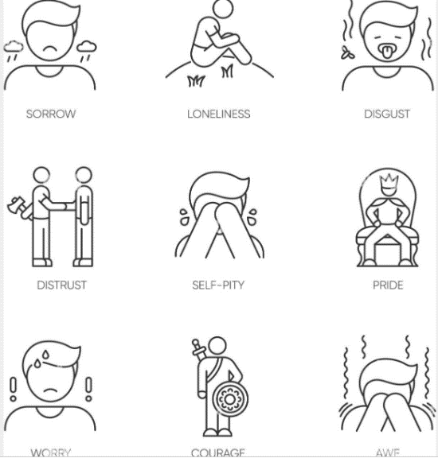  How often do you stay away from school because you will feel sad or depressed if you go?
6 | 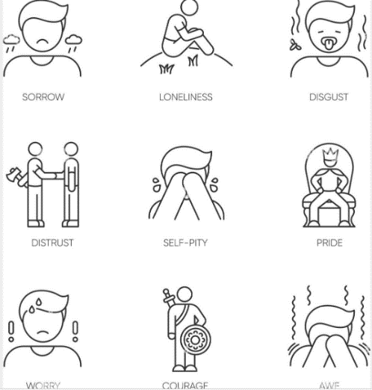  How often do you stay away from school because you feel embarrassed in front of other people at school?
7 |   How often do you think about your parents or family when you are at school?
8 |   If you don’t go to school, do you talk to or see other people (other than your family)?
9 | 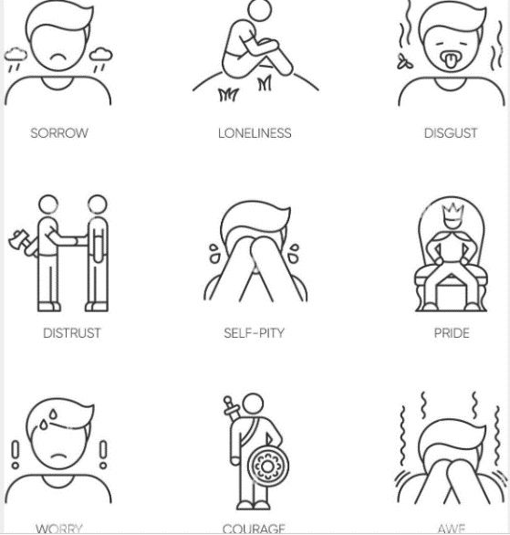  How often do you feel worse at school (scared, nervous, or sad) compared to how you feel at home or with your friends?
10 | 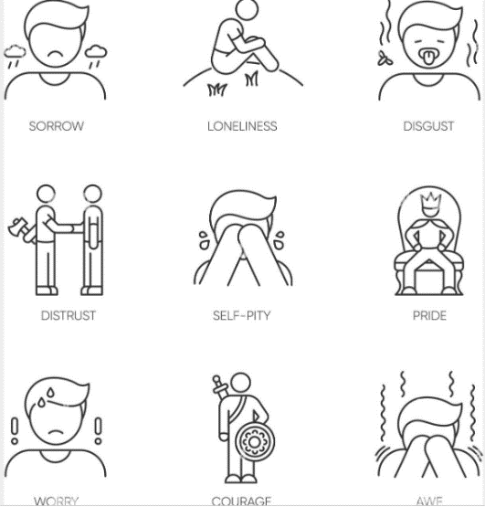  How often do you stay away from school because you feel like you don’t have friends there?
11 | How much would you rather be with your family than go to school?
12 |   Outside of school do you enjoy doing different things (being with friends or going places)?
13 | 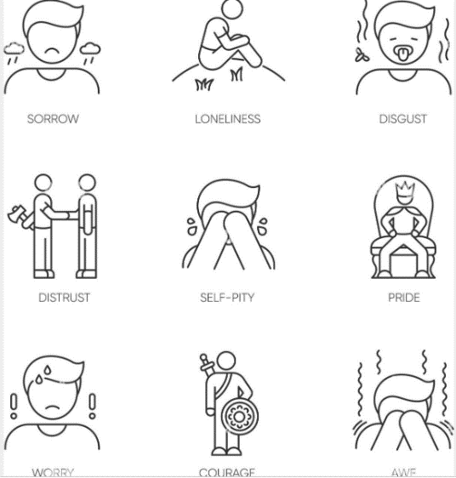  How often do you have bad feelings about school (scared, nervous, sad) when you think about school on a Saturday or Sunday?
14 |     Do you try and stay away from certain places in school (corridors, places where certain people are) because you would have to talk to someone?
15 |   How much would you rather be taught by your parents at home than by your teacher at school?
16 |     How often do you not go to school because you want to have fun outside of school?
17 | 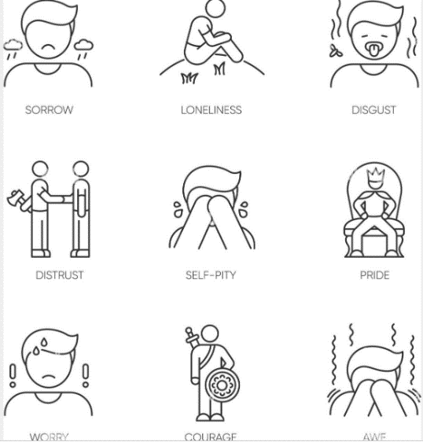  If you had less bad feelings about school (scared, nervous, sad) would it be easier for you to go to school?
18 | If it were easier for you to make friends, would it be easier for you to go to school?
19 |   Would it be easier for you to go to school if your parents went with you?
20 |     Would it be easier for you to go to school if you could do more things you like to do after school hours (like being with your friends, playing games)?
21 | 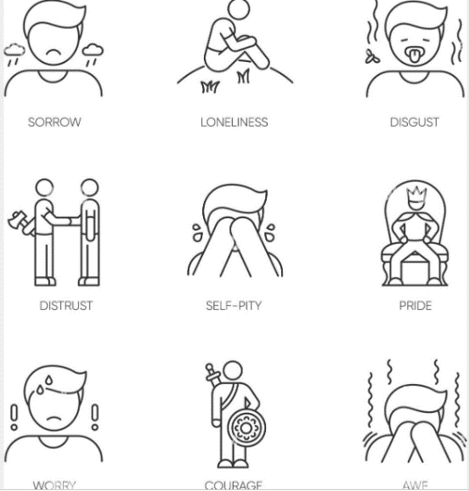  How much more do you think that you have bad feelings about school (for example, scared, nervous, or sad) compared to other kids your age?
22 |   How often do you avoid people at school (when you’re in school) compared to other kids your age?
23 | How much more do you think you would like to be home with your parents more than other kids your age would?
24 | How much more do you think you would you rather be doing fun things outside of school than most kids your age?

Interpreting the results
In the following table, the numbers in each of the four columns correspond to the question number on the questionnaire.
- Write the score for each question next to the number.
- Total each column for the total score.
- Divide the total by six for the mean score.
- Order the four columns in order of highest number to lowest number. The column with the highest mean score can be interpreted as the prevent reason for school avoidance.

 | To avoid uncomfortable feelings brought on by attending school |  | To avoid situations that might be stressful |  | To reduce separation anxiety |  | To pursue tangible reinforcers outside of school
 | 1 |  | 2 |  | 3 |  | 4
 | 5 |  | 6 |  | 7 |  | 8
 | 9 |  | 10 |  | 11 |  | 12
 | 13 |  | 14 |  | 15 |  | 16
 | 17 |  | 18 |  | 19 |  | 20
 | 21 |  | 22 |  | 23 |  | 24
Total score:
Mean score:
Relative rank:

